GEOM99 Web Development Log

Step:1

* 6th March 2024,7:10 to 7:12 PM
* First login into the Google account where you have the Google credit -> First log in to <https://console.cloud.google.com/and> -> go then go to the project My First project (I don’t have a project so I created the project -> Go to this project name tab and open -> click to the new project tab fill the details with location No organization.)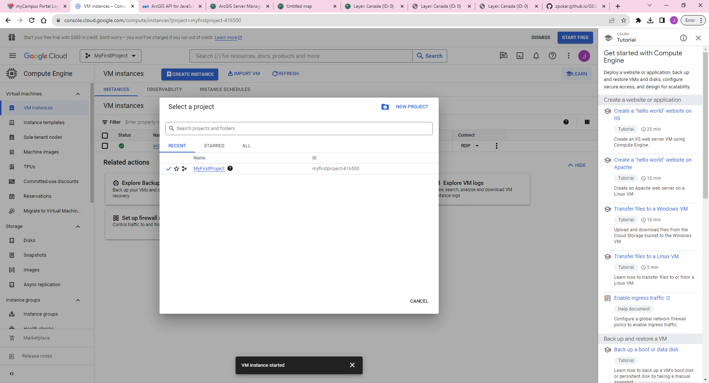

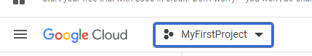

* In the next step I enable the compute engine API and then set the services for this VM.
* Resources: Google Cloud Platform console: <https://console.cloud.google.com/>

Step:2

* 6th March 2024,7:12 to 7:15 PM
* Enables Compute Engine API, which is essential for creating virtual machines on GCP
* Next I go to the  menu and select compute Engine -> VM Instances-> create an instance (click open new window )where I set all the details which are required for this project, most importantly I change the image setting and set it according to the instruction. (Where I go into the custom image settings and select Shawn’s ArcGIS Server, then in the dropdown menu shows the geom992014-v2)
* Next step I enable the firewall services

Step:3

* 6th March 2024,7:15 to 7:19 PM
* First I enable the Firewall services such as allowing HTTP traffic and HTTPS traffic we use this for communication.HTTPS is the secure protocol than HTTP. (HTTPS secures the data before transferring.)
* Hit the create and, it takes a couple of minutes and I have my VM.
* Next step I set the password for my VM.

Step:4

* 6th March 2024,7:20 to 7:25 PM
* After creating the VM I have to set the Password for My VM because of security that anyone can access.

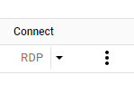

* So, I found out that using the three-dot dropdown menu, I can see the option to set my password. When I clicked on it, a new window opened up and my Gmail ID was automatically populated as the username. However, I changed it to "student" and click on "set" to generate my password.
* Note: I initially set my username as my Gmail ID, but after reading the instructions, I realized that it should be set as "STUDENT". I was unsure of how to change it, so I watched my instructor's video and followed their guidance to update my username accordingly.
* Copy the password and save it in Notepad because it's too hard to remember.
* Resources: <https://youtu.be/dyFeyBX9jIY>
* Next step I set the Firewall Rules for this VM.

Step:5

* 6th March 2024,7:30 to 7:37 PM
* Here I set the firewall rules we set rules for controlling the traffic and preventing unauthorized traffic as well.
* First, I will create the firewall rules. Then, I will set the name as "FLEMINGGRDP444" and set the target as "All instances in the network".
* To set the source filter, select IPv4 ranges. If you're using our system, you'll need to set your system's IP address. However, for this project, we'll set the IP address to 0.0.0.0/0 so that we can access any computer on the internet.
* I need to select the checkbox where I have the option to specify the protocols and port. I will set the port to 444 because I use the on-campus system and this port is set as the default for the custom image virtual machine. For remote desktop protocol (RDP), the default port is 3389.
* Click Create.

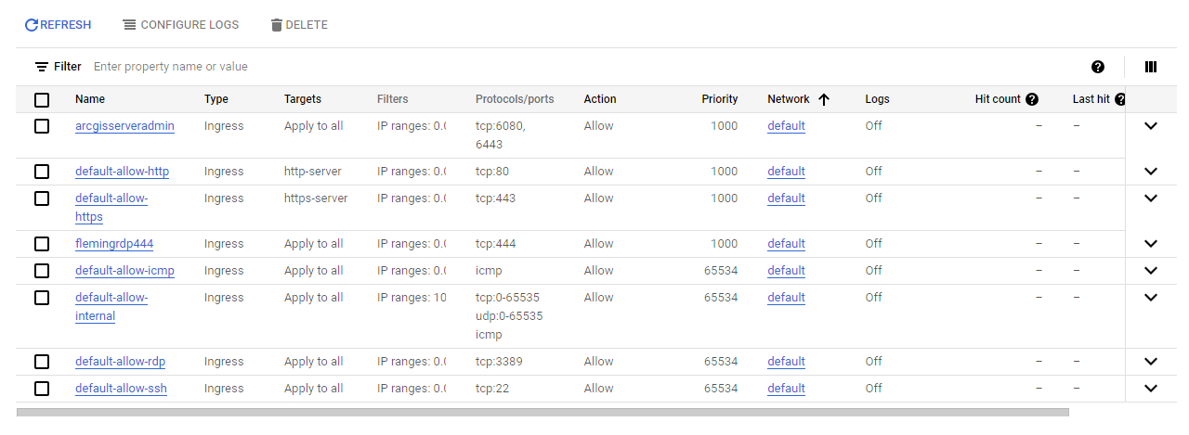

* The next step is to set the firewall rules for the ArcGIS server.

Step:6

* 6th March 2024,7:37 to 7:41 PM
* I set the firewall rules for our ArcGIS server because Google does not open the ArcGIS server port by default. To set up the port, I followed the same process I used for setting up Fleming College port 444. However, in this case, instead of writing port 444, I had to write ports 6080 and 6443.
* Click Create and it takes minutes to load.
* By default, ArcGIS Server supports communication through the 6443 port, and the 6080 port is no longer used for communication in ArcGIS Server. However, we may still use it for testing purposes.



* I set all the settings required for the VM

Set Firewall Rule in the window to allow ArcGIS management ports

Step:7

* 6th March 2024,7:41 to 8:00 PM
* First I login to the VM in the window using Remote Desktop Connection

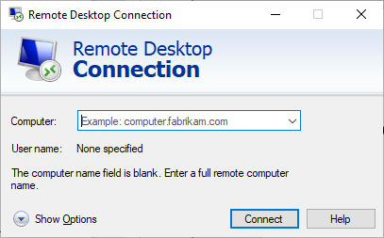

* Login with the External IP address and then pop u7p a new window where I select to use a different user and add username STUDENT and password which we set while setting the VM and when I log in to new windows it takes a few minutes to load.

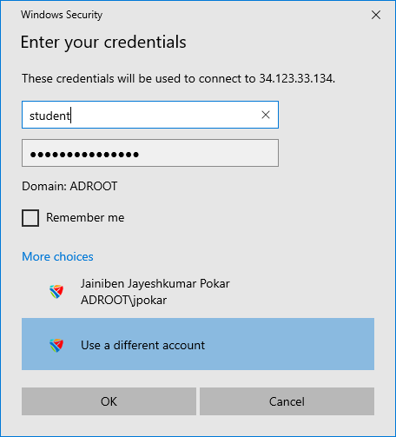

* Next I go into the taskbar search option a search ”Firewall “The one open will appear like Windows Defender Firewall with Advanced security -> select that open one window like below -> next select the Inbound Rule from the left side content bar once clicked on it on the right side we can see the item bar than select New Rule form there.

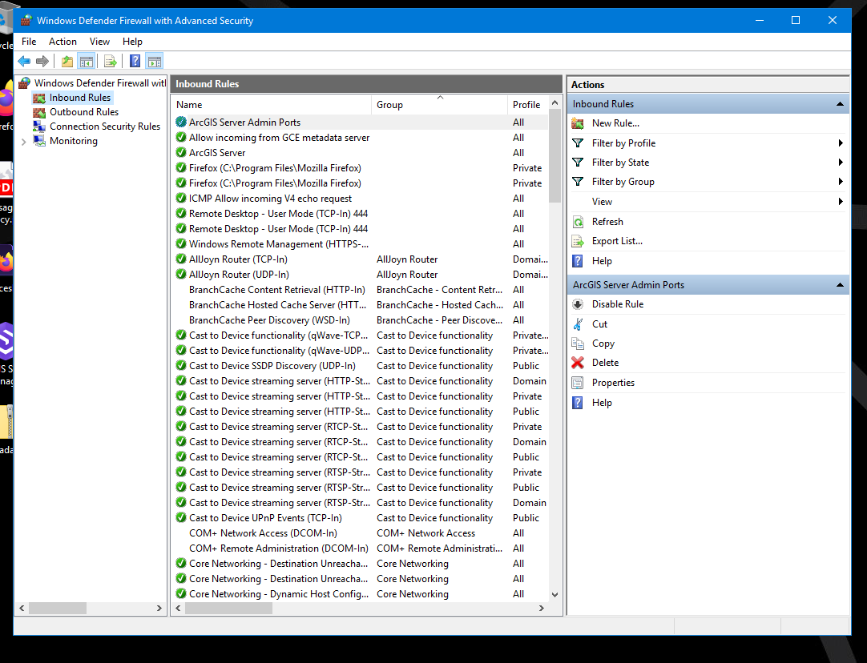

* Once we select open new window there first set the rule type there I select port -> then the next step will appear there I select TCP(we select the TCP port because we used the TCP port ) after selecting the TCP port we have added the port number their I add 6443 and 6080 than click Next Button new setting more ap their we don’t have change anything because it is correct so again click next.
* Then give the name to the rule “ArcGIS Server Admin” and click FINISH.
* Here I am done with setting the rule for the ArcGIS server in VM Window.
* Next step I go back to the original window and try to open the link and check how it works.

Step:8

* 6th March 2024, 8:00 to 8:07 PM
* Next I try to open the ArcGIS server link <https://34.135.95.123:6443/arcgis/services> here I use the 6443 port because without that this link is not working and once we stop the VM our Ip address will change so we have to change the Ip address every time if we stop and start the VM.
* Once I go on this link it shows the window with an unsafe message like YOUR CONNECTION IS NOT PRIVATE below this line there is one button Advance once I click that button new message will appear and then I click on proceed to *IPNUMBER*
* Then open my ArcGIS Rest services.
* Next try to open the ArcGIS Manager [https://34.135.95.123:6443/arcgis/manager](https://34.135.95.123:6443/arcgis/managers) -> once I open this link we have to go to the same process as the one we did in the services link (about unsafe massage) then one login window appears there We have added the username STUDENT and password which we set while setting the VM.

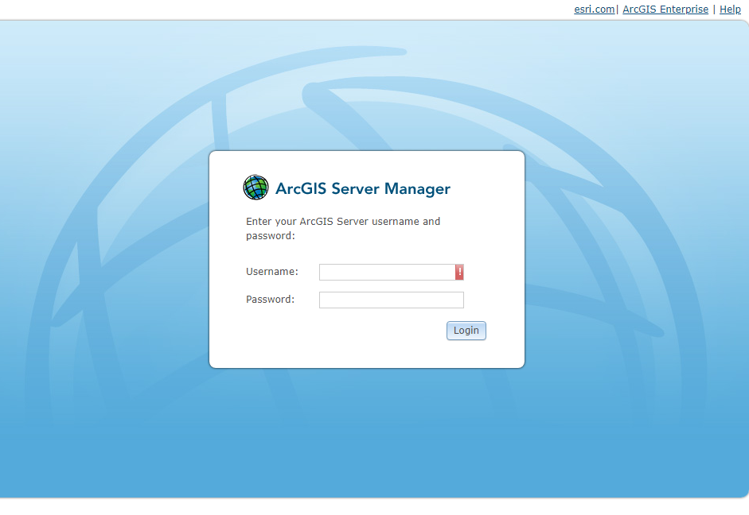

* Next step I go back to the original window and Stop VM.

Step:9

* 6th March 2024, 8:07 to 8:10 PM
* Next I stop the VM -> go to the Google Cloud Platform and on the VM instances then again go to the third dot menu where we set the password for the VM now I select the Stop option and click In a couple of minutes my VM will Stop(if I didn’t shut down my the remote Desktop connection than its automatically close once I stop the VM)
* Now I am again on the VM Machine and publish the map on the ArcGIS server.

Step:10

* 6th March 2024, 8:10 to 8:35 PM
* After starting the VM, again I login into the Remote desktop Connection, and then the remote window on the Desktop there is one Canada folder-> copy that folder content and paste that into this(C:/gisworkspace/Canada ) directory.

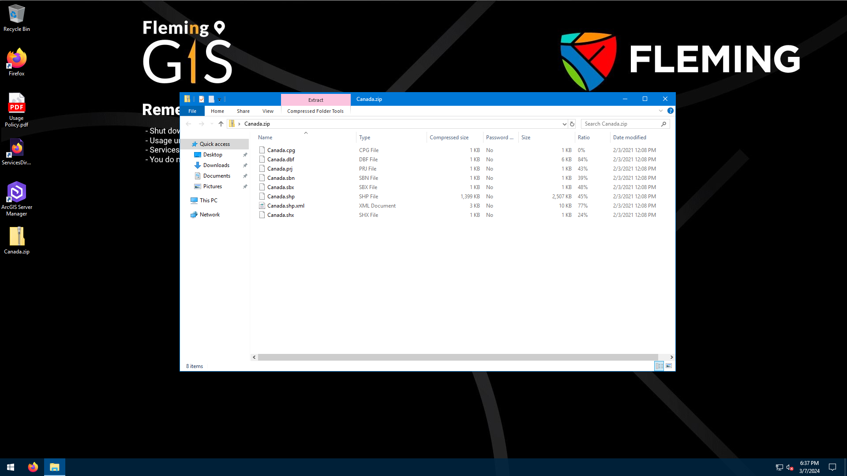

* I started by creating a new project in ArcGIS Pro. Then, I added the Canada shapefile to the map. Next, I decided to change the cartography of the map. Then, I went to the Insert tab and clicked on Connection. From there, I clicked on Server and then clicked on New ArcGIS Server. This opened a popup window that allowed me to add a new server. (I already have the necessary file in my "c:/gisworkspace/canad" folder, as I used it in the past week. If you need to download it then download it from the week 7 checklist, make sure to save it in the same directory on your C drive.)

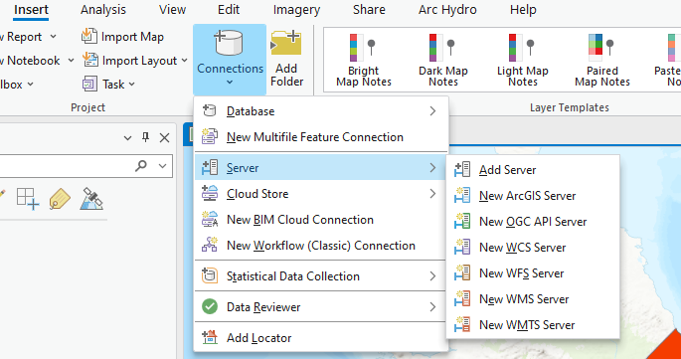

* In the pop-up window, add the Server URL. I should make sure to use the external IP address from VM [https://34.135.95.123:6443/arcgis](https://34.135.95.123:6443/arcgis%20) and provide the username and password which were provided in the week 7&8 checklist for authentication. Once I have added the credentials, I will click on OK.

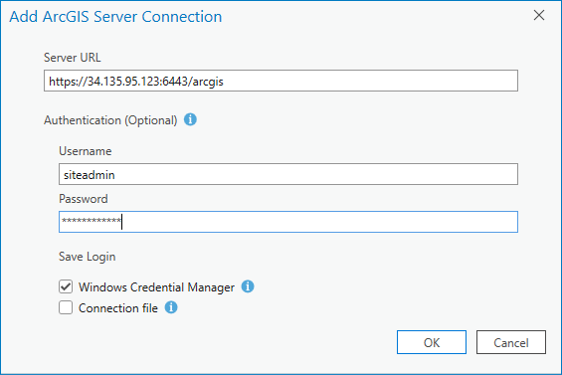

* After clicking OK, a pop-up window appears regarding the certificate. If you click on "View Certificate" (as shown in the picture below), simply close the certificate and click "Yes". It may take a minute, but afterward, you should be able to see the server connection in the Catalog pane, under the server folder. ( arcgis on 34.135.95.123_6443 (1).ags )

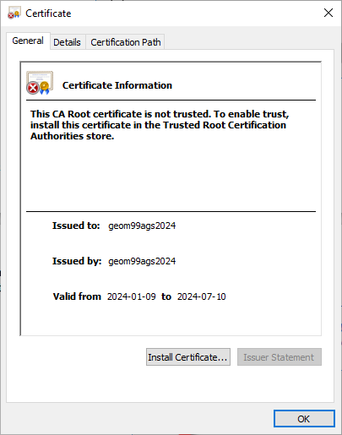

* To publish my map, I first had to find the server connection in the catalog pane. Once I found it, I right-clicked on it and opened a list menu. From there, I selected "Publish" and navigated to the map. Open one new popup window then click on the map from your ArcGIS project, and then click "OK" to confirm my selection.

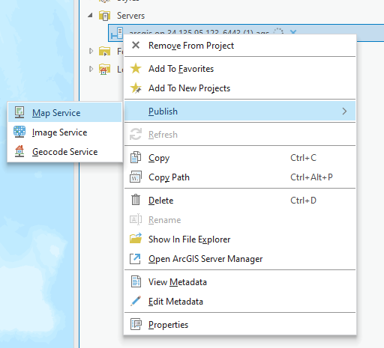

* After clicking new content come in the catalog pan there we have to add the name, description, tags, and folder name then click analyze.

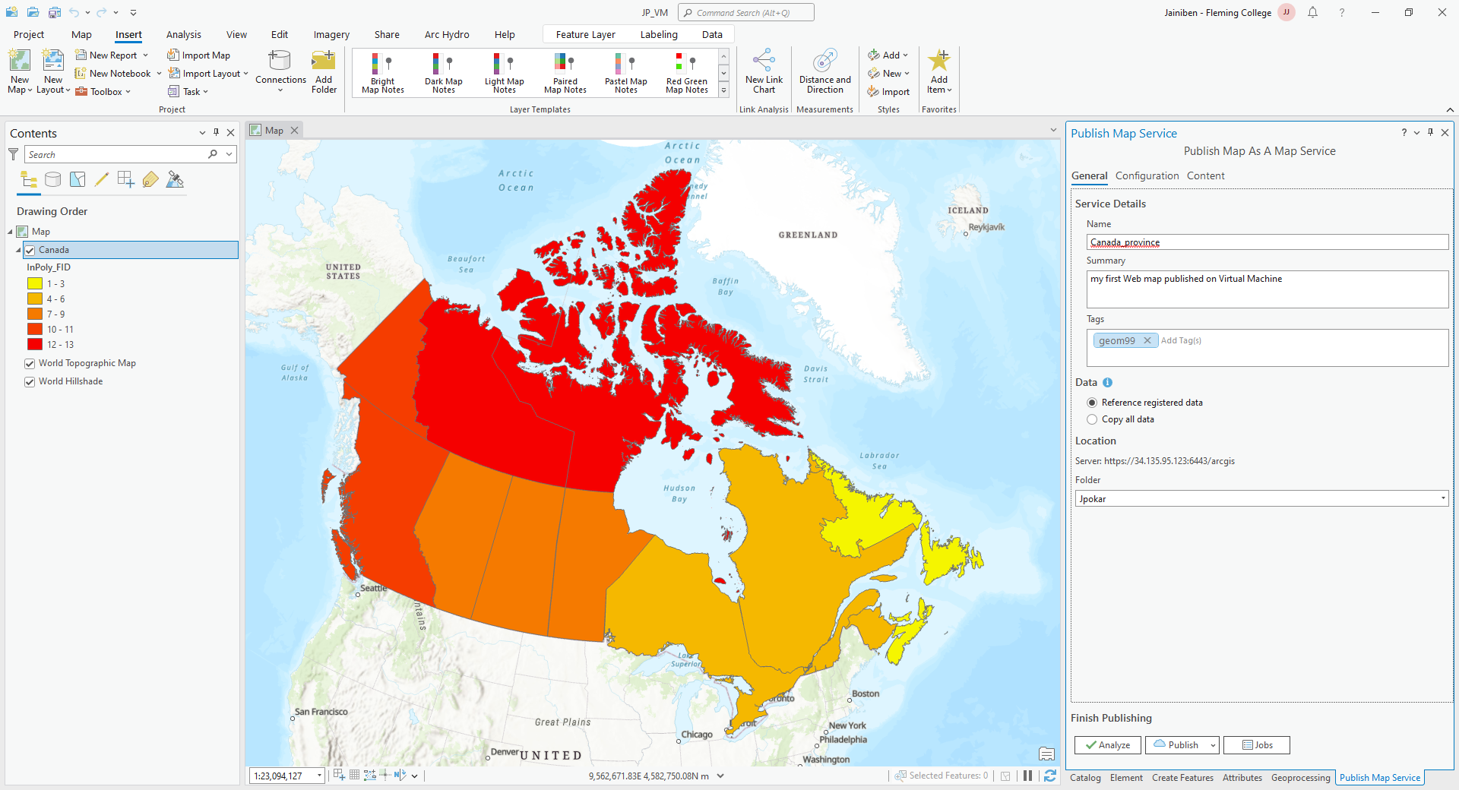

* Once I proceed, I may encounter an error message. One of the errors could be related to a unique sequentially ID, which can be resolved by right-clicking on the error and selecting the "auto-assign ID" option. This should resolve the error and allow me to continue with the task at hand.

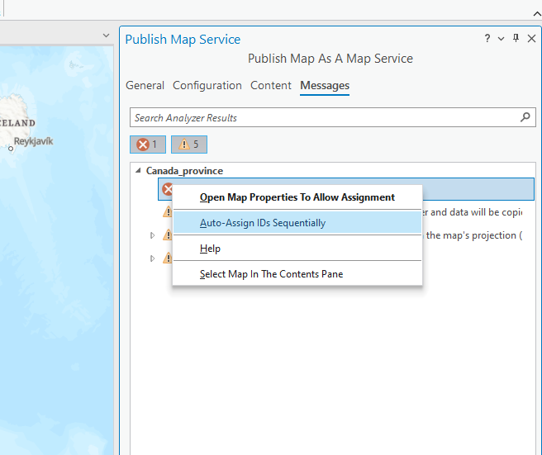

* I have encountered an error regarding data source registration. To resolve this error right right-click on the error then select the first option, provide the C:/gisworkspace path, and click "OK" to make the error go away. Although, I may encounter a warning about the base map projection which I'm not sure how to resolve. Once the issues are resolved, I can simply click "Publish" and wait a few minutes until it completes.

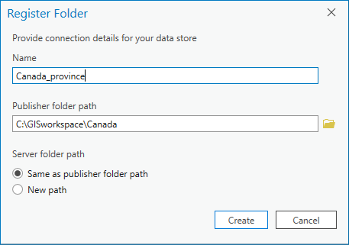

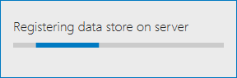

* After selecting the map and confirming my selection, it took a couple of minutes for the data to publish on the server. However, once the process was complete, the map was successfully published and available for others to access.

Step:11

* 6th March 2024, 8:35 to 8:38 PM
* After that we can see that published map on the rest service directory there you can see the folder name that you provided while publishing the folder URL<https://34.135.95.123:6443/arcgis/services>

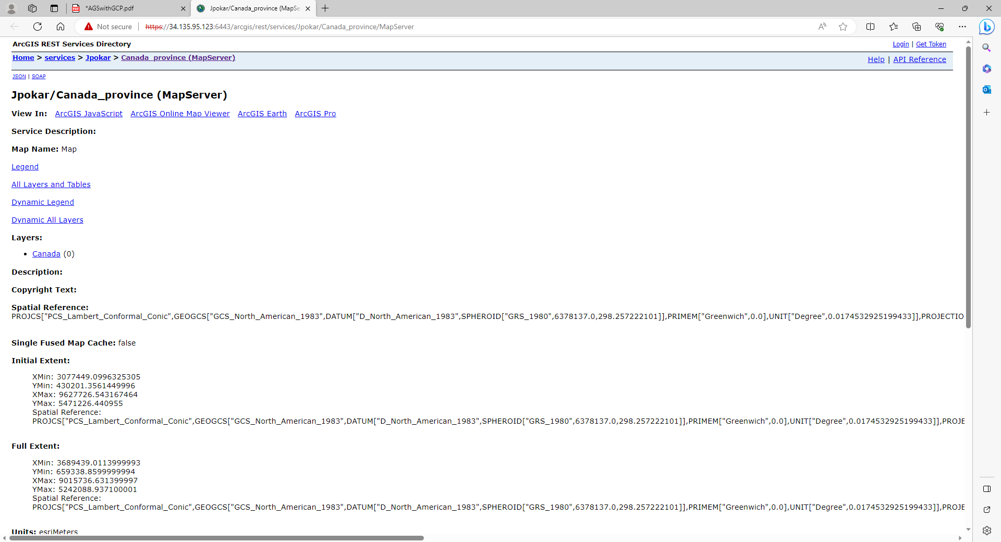

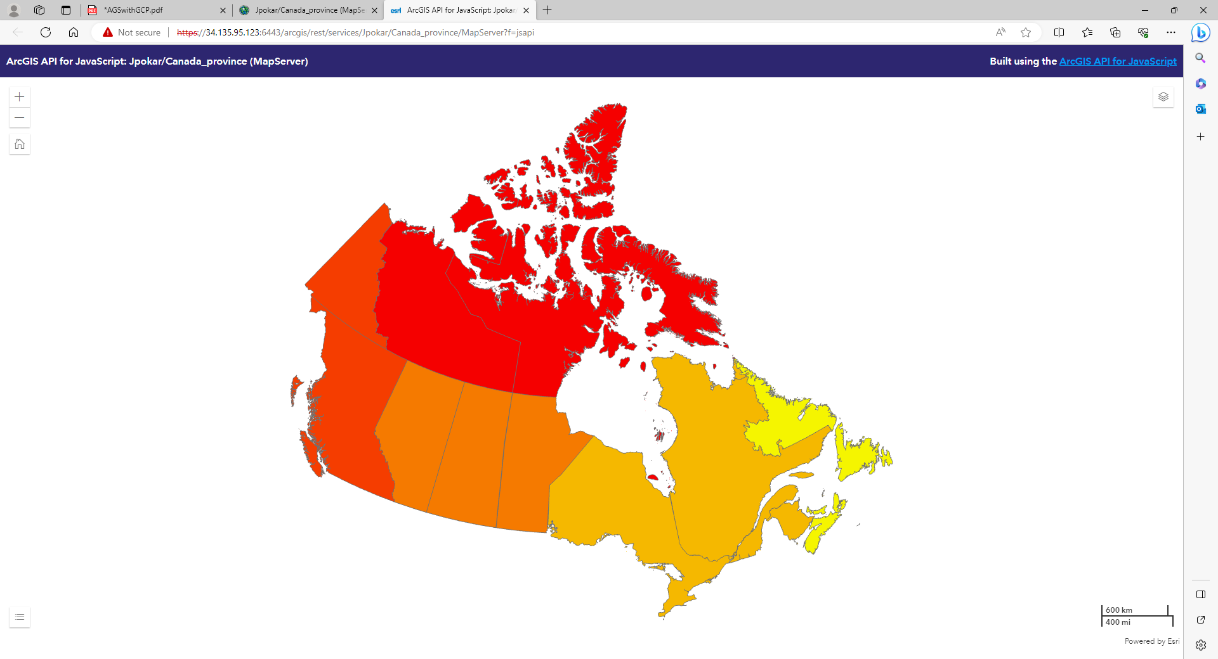

Published map services add on arcGIS online

Step:12

* 6th March 2024, 8:38 to 9:30 PM
* So, I wanted to create two web maps using a published map rest service URL. I first accessed ArcGIS online and went to the content section. From there, I clicked on the 'new item' option and selected the URL. This opened up a new window where I had to copy the URL, one with a 6443 port and the other without a 6443 port. Finally, I was able to create two web maps using this process.
* (here I faced one error I opened the rest directory without opening the remote desktop so it showed an error than login into the remote desktop and open the URL then do this step)
* After copying the URLs, I clicked on the 'next' button and was prompted to enter the title of the map along with tags and a summary. Once I entered all the required details, I clicked on the 'save' button to save the changes.

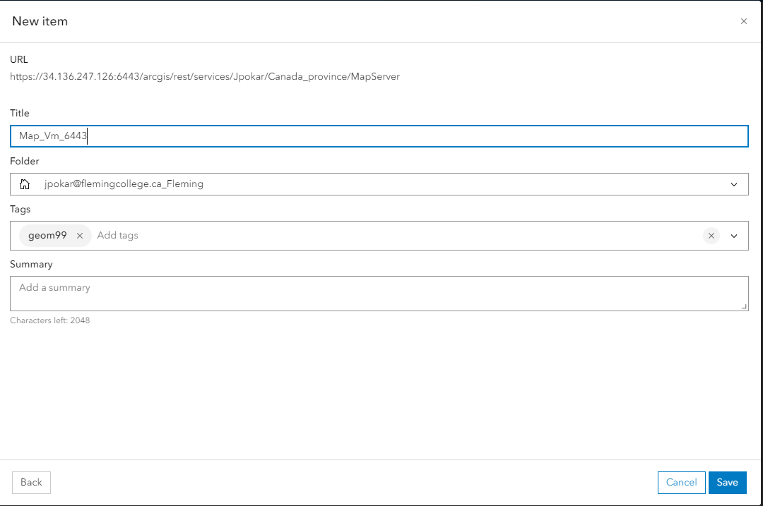

* Map Without port number: <https://fleming.maps.arcgis.com/apps/mapviewer/index.html?layers=cfba86fa068341689b269e10bb95b0ec>
* Mao with port number: <https://fleming.maps.arcgis.com/apps/mapviewer/index.html?layers=5643d7c7e6934988aea20c41d6672755>

Total Time: 2 hours 20 minutes

**DUCK DNS**

**Step-13**

* 7th March 2024, 8:23 to 8:43 PM
* Watch video how to make domain on DUCK DNS , I confused why we use DUCK DNS and what is purpose of that on google. <https://medium.com/bina-nusantara-it-division/connecting-your-local-network-to-the-internet-with-duckdns-6febffc7b93c>

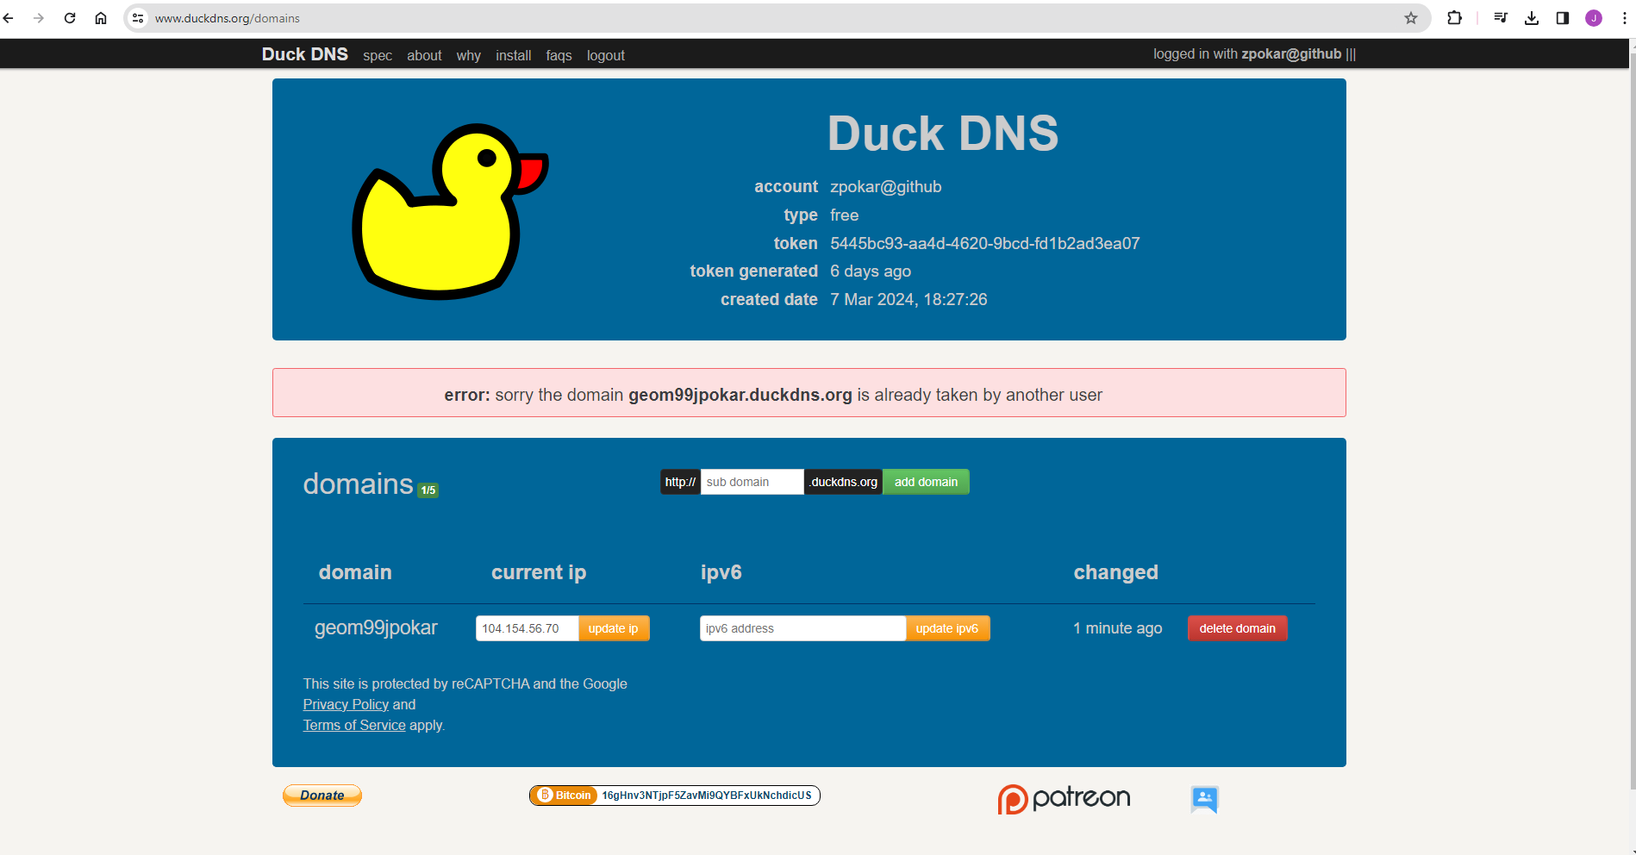

* Than I create the account on the DUCK DNS and using the github account and create the domin name add the ip adress form the VM instence for activate it.

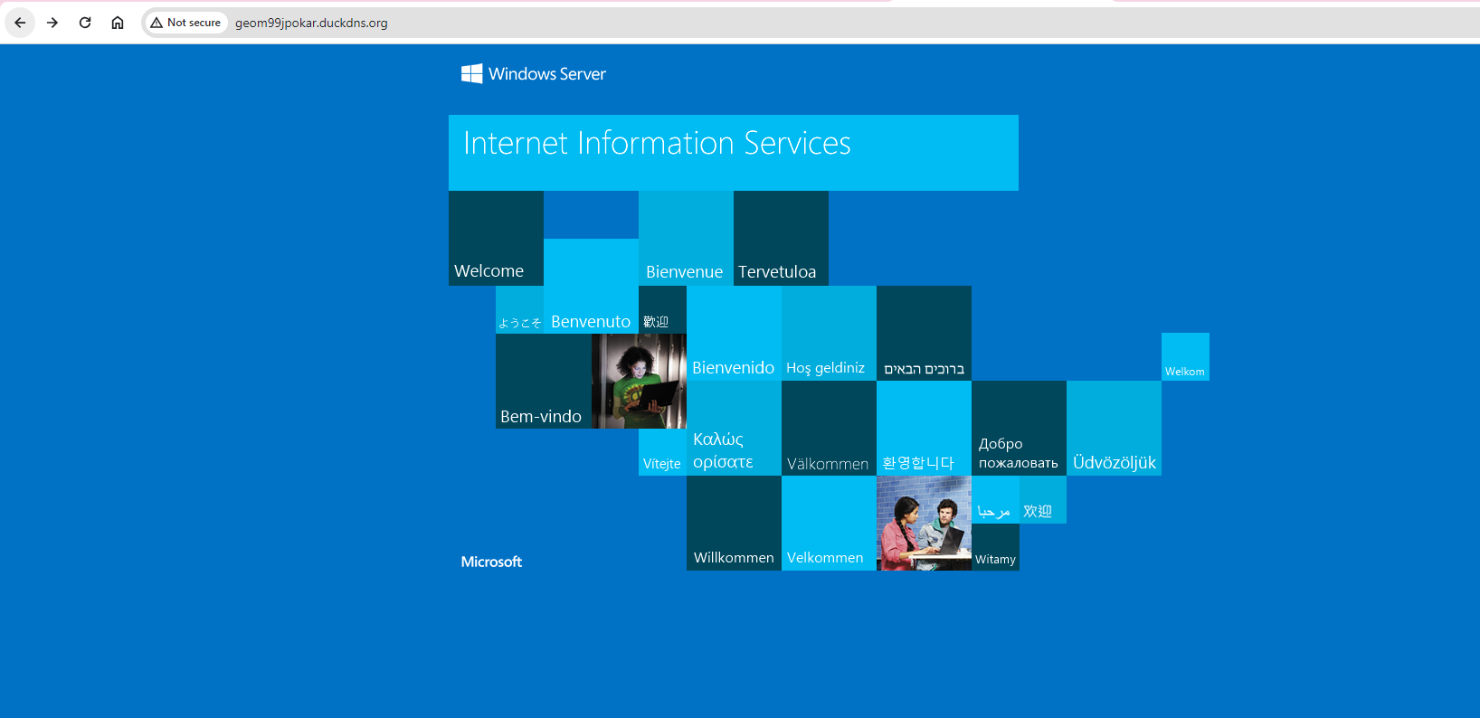

**SSL Certificate**

**Step:14**

* 7th March 2024, 8:50 to 9:40 PM
* Then login in to the remote desktop and than go in to the Firefox browser and and download the win acme

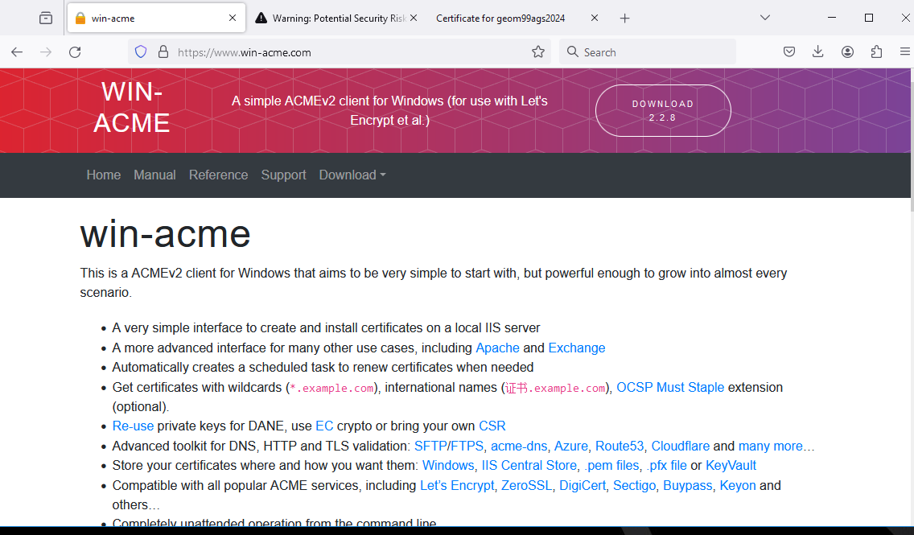

* After downloading that , it downloaded in the zip file so than I unzip that and install in the system using the exe file first I just double click but is not work than I right click on the file and the click on the run as administrator

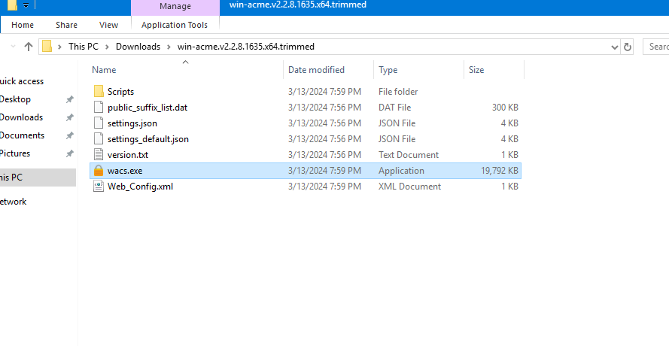

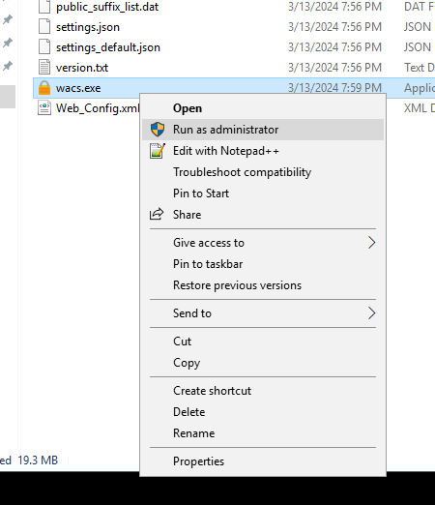

* After that I go into the search section in the start bar and search IIS Manager and open that the on the left side there is connection section in that section we have click on the default website.

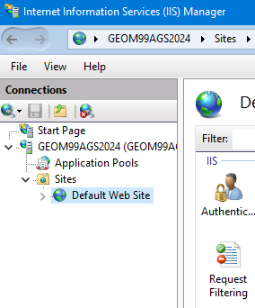

* Ater that I go to the right side and there is on action section and go to the binding part and click on that open one window.

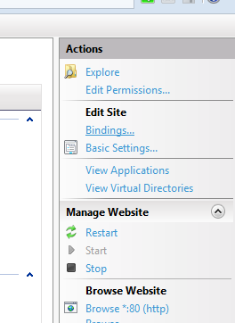

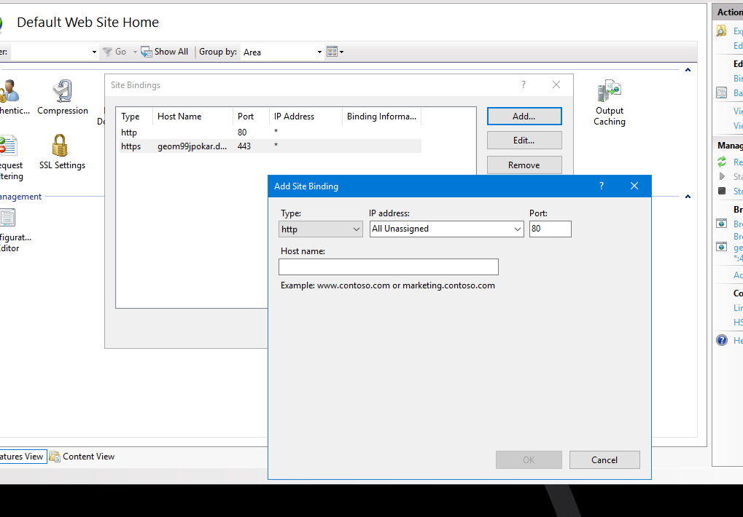

* In this window here I click on the ADD button and the one more pop-up window will appear on that we have add the hostname of duck DNS example:<geom99jpokar.duckdns.org> and click ok
* After that again I go to the Firefox browser and using the DUCKDNS hostname geom99jpokar.duckdns.org past this in the new tab after couple of minutes something comin on my window with the warning this site is not safe like

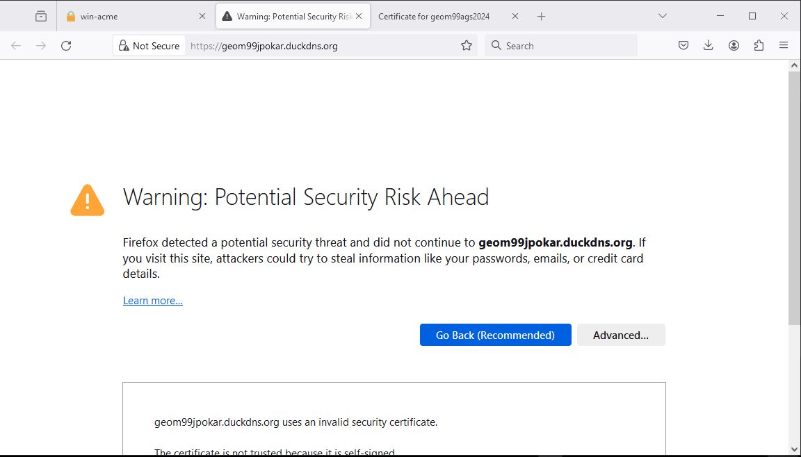

* Then I click on the advanced and the below appear one small section where view certificate option will show then I click on that and see the certificate than print the certificate.

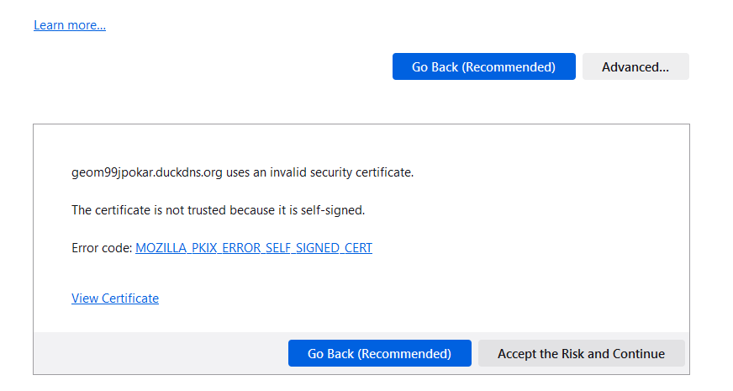

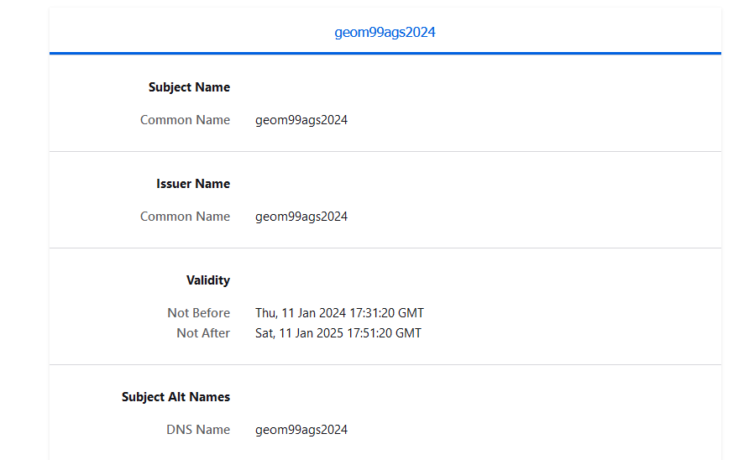

**Total time: 1 hours and 10 minutes**

Group Meeting

* 8th March 2024, 10:47 to 11:48 AM
* First, I attend the class at 10 AM than I create the group on the Microsoft teams at 10:47 AM and than we discuss about our problem statement and than we have meeting with the professor about the out problem statement at 11:00pm on the team he provide guidance about that.
* After the that meeting we guys had one more meeting with the group members and we discuss about the p[problem statement the realistic problem and which data and the what the software we use for this product.
* 9th March 2024,2:00 to 3:00 PM
* I do the research about our problem statement and then I found that we can use 3D map so we need the 3D base map for the out product than I visit the ArcGIS API site and see the tutorial for that<https://developers.arcgis.com/javascript/latest/visualization/3d-visualization/cities-in-3d/#visualize-buildings-as-3d-objects>
* Then make code on this tutorial so I know is actually work for us or not.
* 12th March 2024, 9:30 to 10:00 AM
* We had a meeting with the out collab project client, but he did not come in the meeting.
* 12th March 2024, 11:00 to 11:10 AM
* We had meeting we Kendra and we discuss about our client and we ask the question to her about project.
* 12th March 2024,2:00 to 3:10 PM
* We discuss in the group about what kind of risk we are facing actually how we think to resolve this than we find one issue that if user find any problem or risk they want record that risk and location for that we think we have use the Arc Field Map or Survey 123.
* Then we decided to everyone do the research that we one is the best for the field.

**Total timing: 2 hours 50 minutes**

Group project discussion and week 11 log

* 15th March 2024,11:20 to 12:48 PM
* We had a discussion with my professor, and we came to the conclusion that we were working on the wrong topic. Our intended topic was augmented reality, but we were researching and working on 3D modeling risks. Specifically, we were looking into the types of risks that users may face in the real world, such as those related to pipelines or waterlines. We need to correct our approach and focus on our intended topic to make sure our research is relevant and effective. But then our professor said you guys change your problem statement.
* After that meeting with professor we change the topic and we discussing the whole scenario and the risk which were actually face by the person when they create 3D model for the location and so if they have 3D model than they show the data and identify the risk we guys are discussion on this topic and how we have to implement this and what kind of data we use for this how we can create the map and how we can published that all things we discuss on that day in our group meetings.
* Then we distribute the work and individual.
* 16th March 2024,10:00 to 11:45 PM
* I recently did some research on ArcGIS Field Map. After attending a project client meeting, I learned that we will be using this field map for data collection in our project work. I wanted to make sure I understood how it works and its functionalities to ensure efficient data collection. I went through the Week 9 checklist to get a better understanding of the tasks related to ArcGIS Field Map. It's important to be prepared and informed to ensure a successful project outcome.
* <https://www.esri.com/en-us/arcgis/products/arcgis-field-maps/overview> in this application we can create the from for the user for collecting the data or locating the feature and then we can easily share, it easily assessable in the mobile phone as well.
* After seeing this application I am so confused between ArcGIS field map and survey 123 because both work similar and both Esri product but idk what the difference between them I just google it the different between the this application and I got this link and I read this answer and some what my idea will clear (ArcGIS Field map is more map centric application and where the survey 123 is more survey based or data collection base even survey 123 is easier than ArcGIS Field map) <https://community.esri.com/t5/arcgis-field-maps-questions/is-field-maps-good-choice-for-mixed-methods-map/td-p/1386258#:~:text=Survey123%20is%20much%20easier%20to,multiple%20options%20on%20a%20field.>
* 19th March 2024,10:00 to 10:25 AM
* Again I had meeting with my client and we discussed about the data which data we will use and which software we will use the for the data visualization meanwhile our guide told us that we have go on the filed to collect the data and then creating the map for that we have use the LMX200 GPR(Grounding Penetrating Radar)we discussion that how it work and all.
* Then I asked him what kind result you want form us then he said they want the one ideal 3D model which he can represent on the Ministry of Ontario Park and conservation, and he give the example like if we see the 3D on the Apple Vison Pro.
* 20th March 2024,11:00 to 11:45 AM
* After I sent the massage on the group about the discussion I research on the software and found this and all stuff after that I watch the one video which is suggested by our client how 3D model work<https://www.youtube.com/watch?v=kVsj6Z7UuLY>
* 21th March 2024,7:30 to 8:23 AM
* I go through the ArcGIS dashboard for the ,it create the real time data model where we can view and monitor the event or make decision on the live event as well see the trend and for how it working I did the activity where I create the dashboard and see how its working .

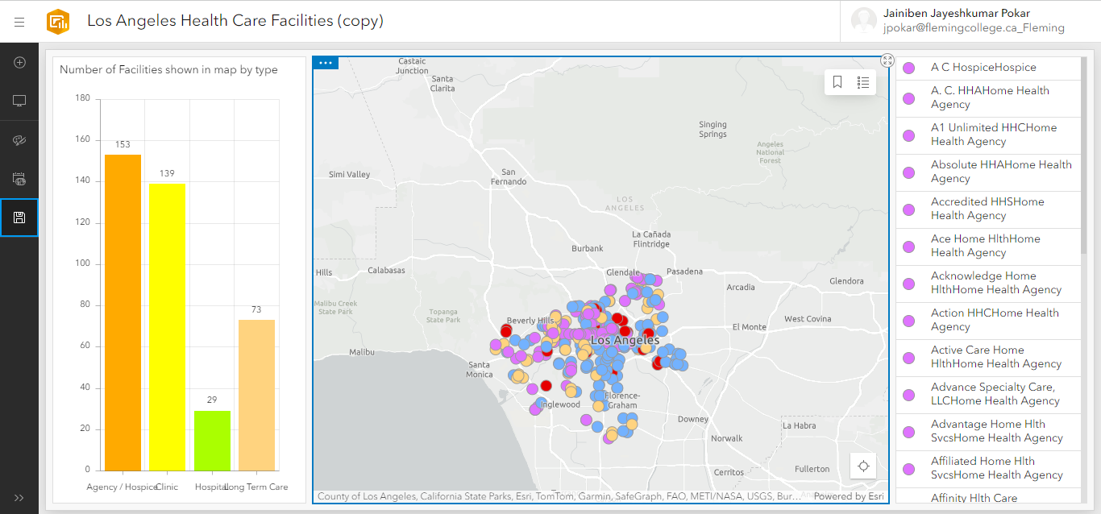

* 21th March 2024, 8:30 to 8:50 AM
* Then I see the ArcGIS hub with out coding we can create the application and easily and responsive as well even we can customized the Application.<https://fleming.hub.arcgis.com/search?collection=App%2CMap> then I see the video which is provided in the week 9 checklist but I did found that same option on the my college account.(I tried but I didn’t figure out than watch whole video and understand how its working )
* 21th March 2024, 8:52 to 9:35 AM
* Experience Builder : I tried to create the experience builder before, I already go through the documentation but I wan tot tried so I watch the video how to create the and then u create the launchpad one because it flexible and easily understandable for first time user , even Experience Builder is integrated with the survey 123 ,Dashboard, Arcgis Field map so we if use can collect the data we can access here .

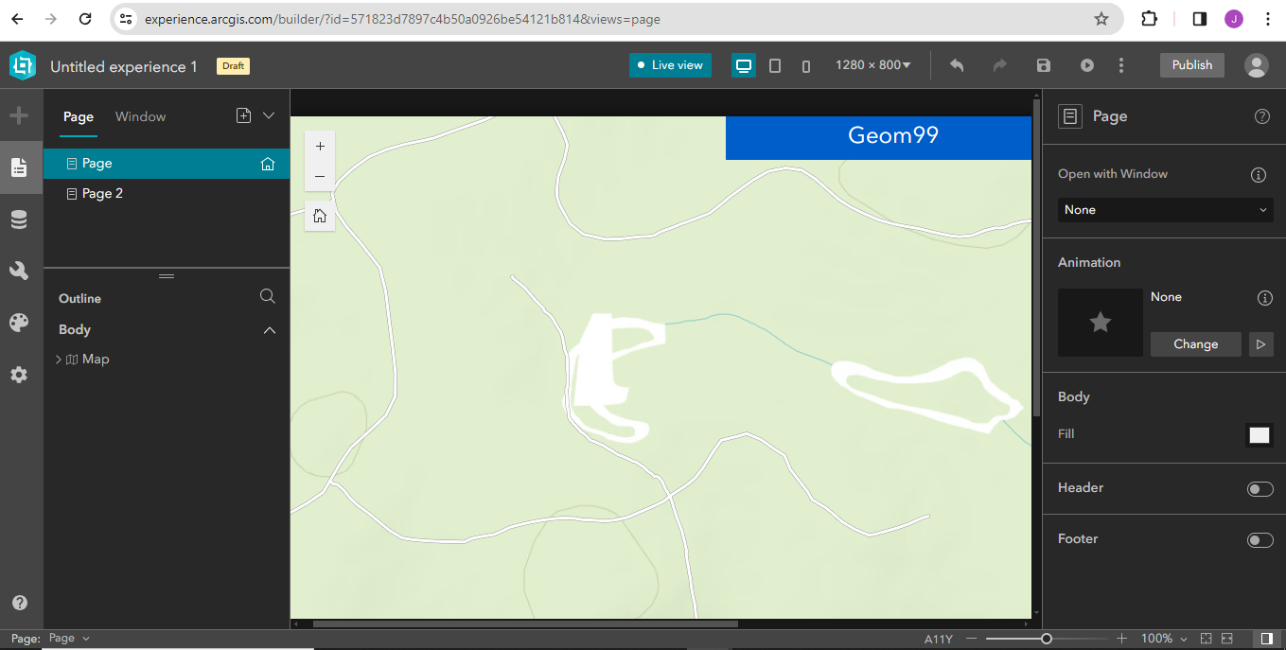

* I created for the live and see the how functionality work and the page I still not complete this I save as draft.

**Total timing: 5 hours 12 minutes**

**Week-12**

* 22th March 2024,11:00 to 11:29 AM
* Before the meeting we discussed on the team what we guys are done in the week, then we have meeting with professor there we discuss our stuff and then we understand we not giving our 100% to the project so we have focus on that we don’t have to create research only we have try and test the software as well.
* After this review on the meeting, I understand where I am wrong.
* 23th March 2024, 1:00 to 2:30 PM
* I tried the Kobo Tool application I download that and make form on that app this form I created on the logic when use see the 3d data then if they look any risk in the area or they want survey so they can collect the data.
* First, we have go on the site and the login than we have start new project, then the one form layout will come something like below

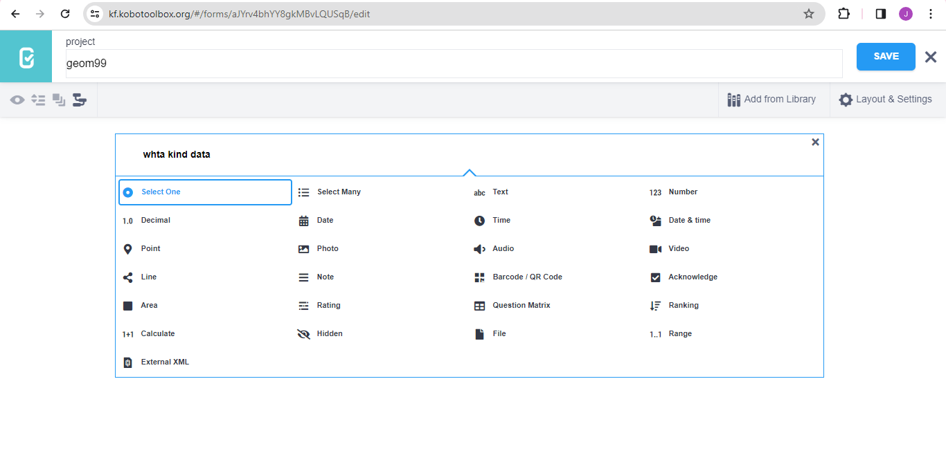

* Then we have to add the question and the question type , here you can show as well which kind of the option we have for the question type.

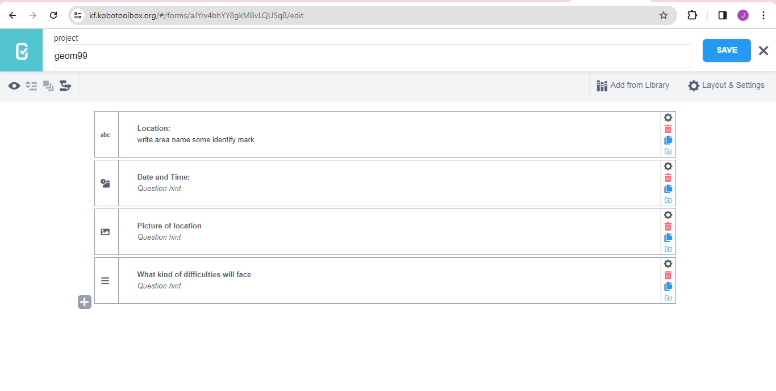

* I created the from like this which you can see above, after that I set the privacy or sharing settings we have enable the setting for the like only one person can add the data at a time or multiple people can.

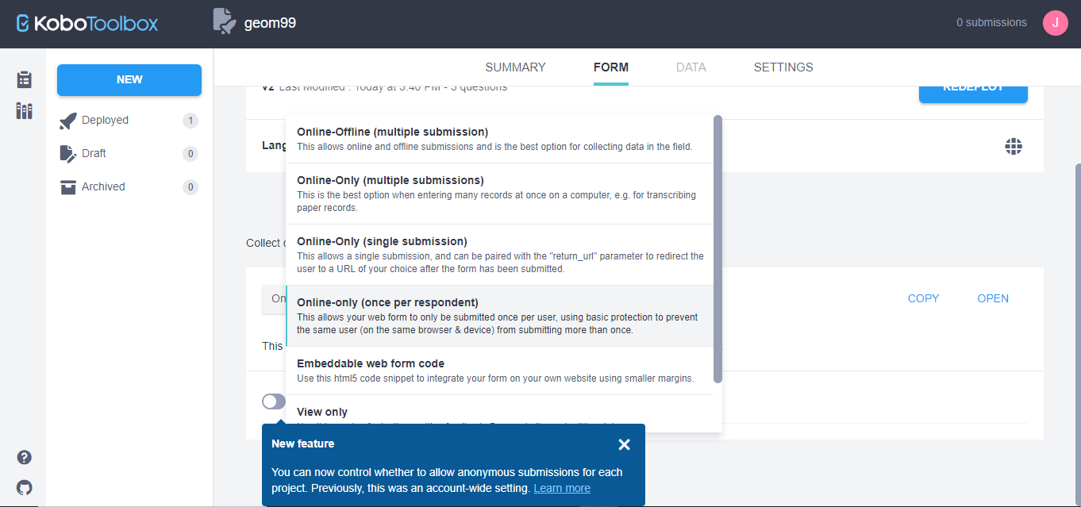

* This is the link of the from which I created: <https://ee.kobotoolbox.org/x/3DPvIQYU>

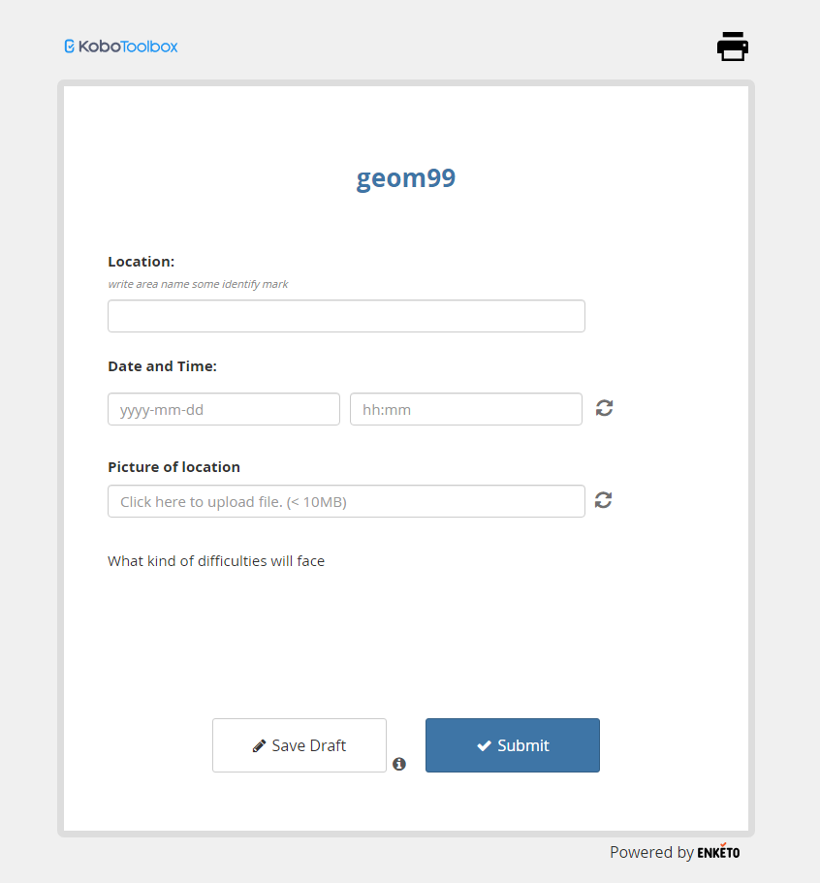

* After that I explore one more application ArcGIS Field map on that I also create the form because that form we can easily connect with the Field map but here I found one problem I don’t know field map is connect with the arc scene viewer or not because out project is based on the 3D data.
* First login and then click on the new map then new we will come there we have to provide the layer name and the which type feature layer we want to create like point/line and polygon select and then second step we have set the layer settings there is the three question ill come if you want that setting then we have switch the switch button to enables.

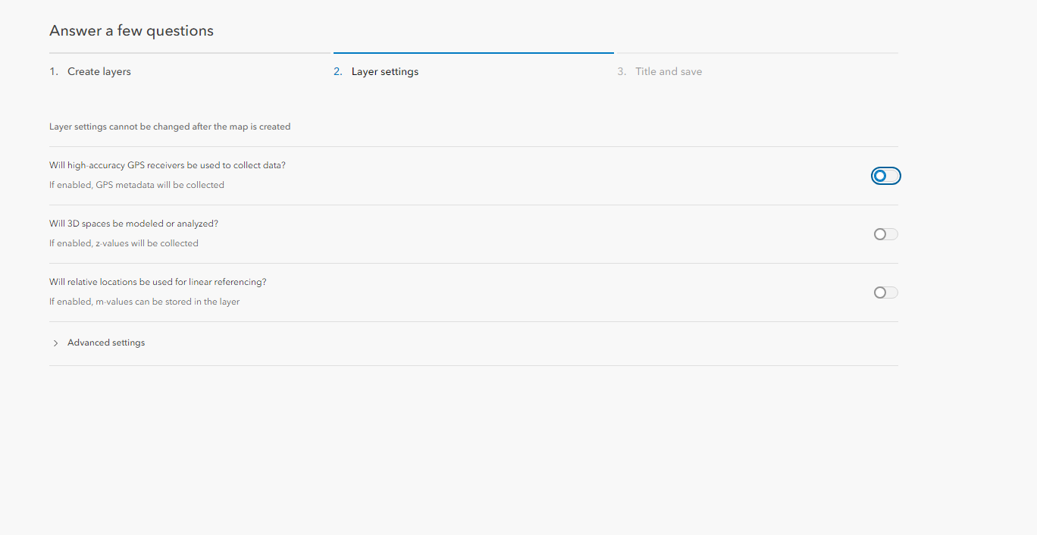

* Below that setting one option for the advance setting there we have select the which coordinate system we will using while collecting the data.

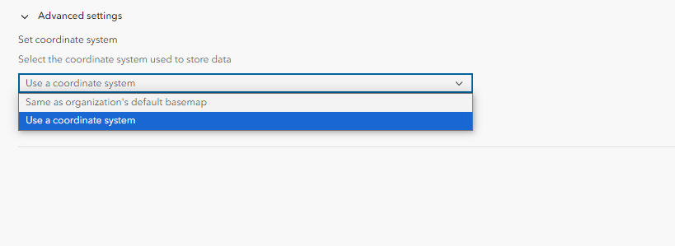

* Then you have to select the layer which you created then we just have top do the drag and drop the option which we want in our project such as textbox, line, comment box, list and create the form.

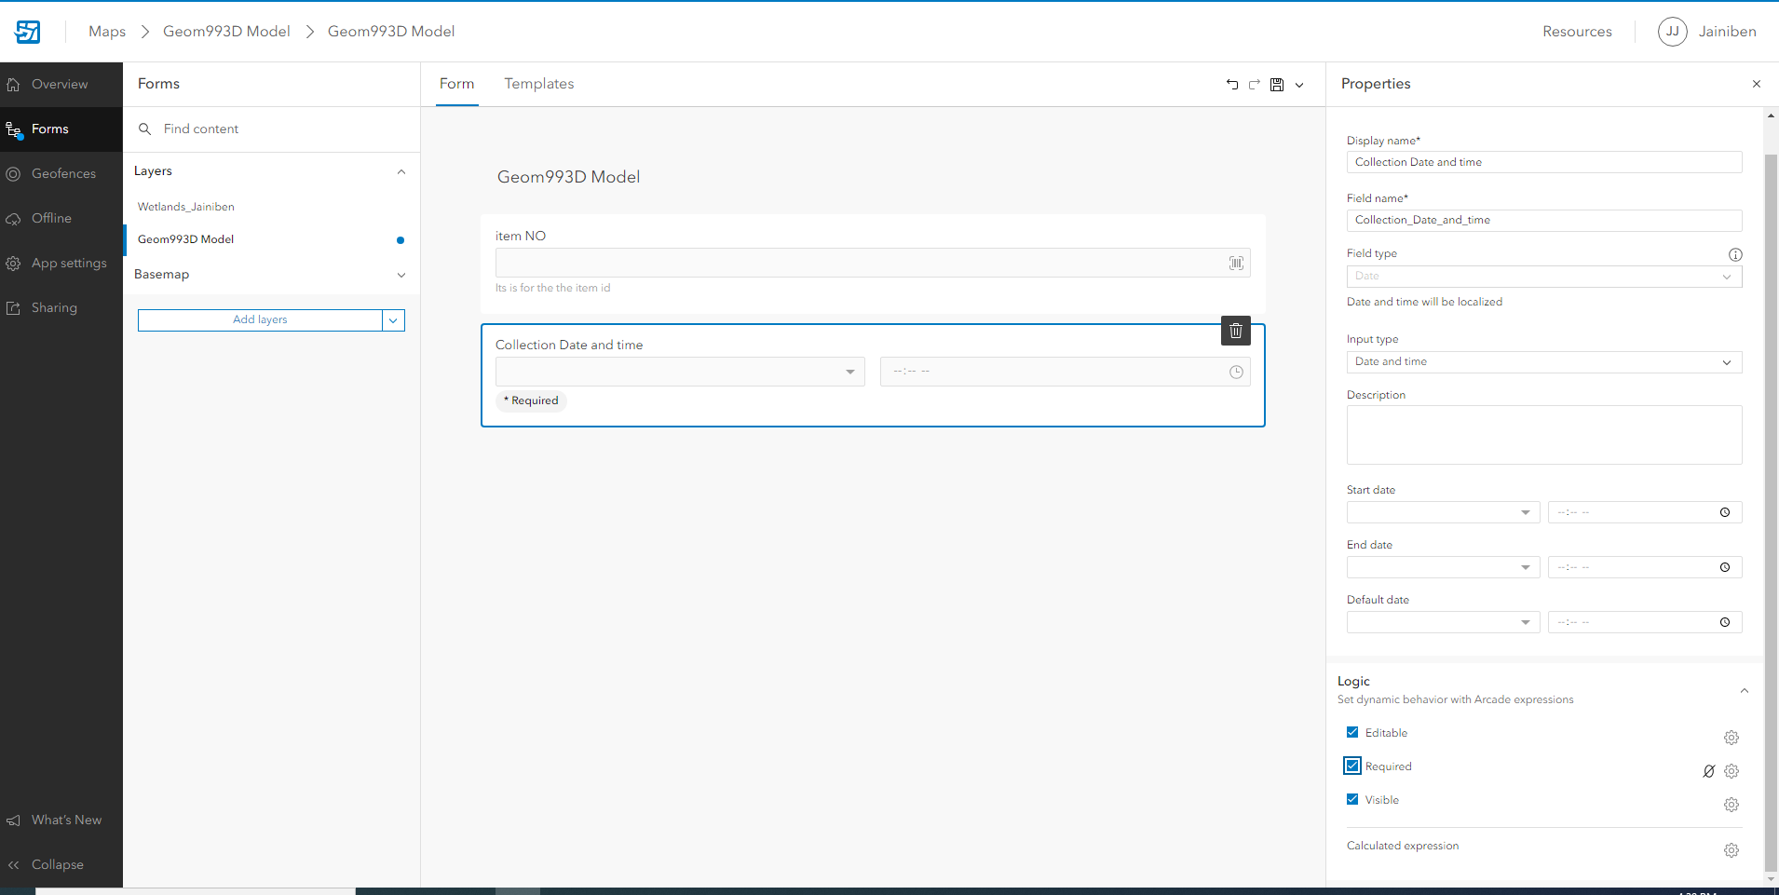

* I created this form where we add the risk data on the site .

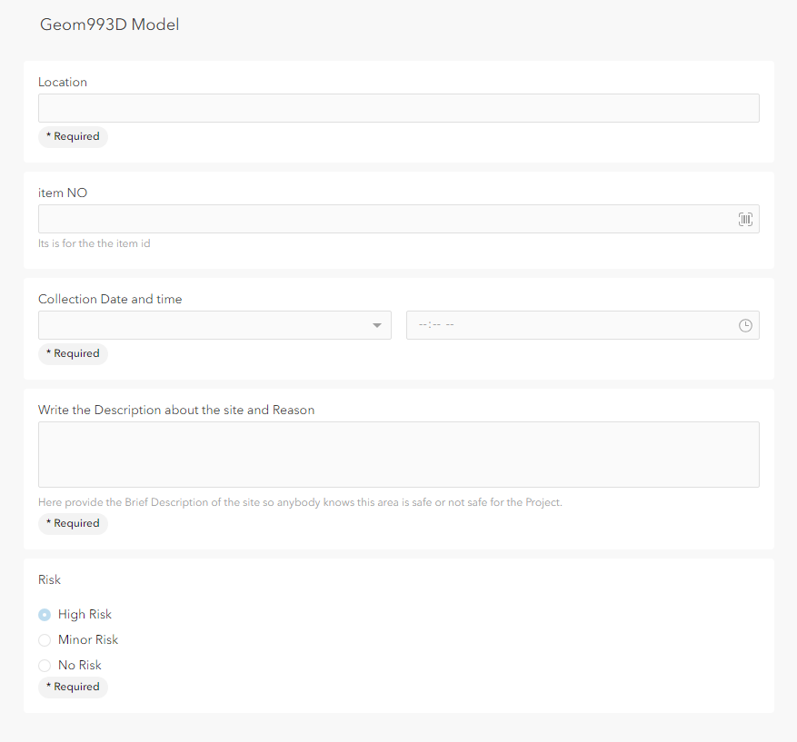

* Then I published that from on the my ArcGIS online account then I open that on the arc map; viewer and try to collect the data fille the from.

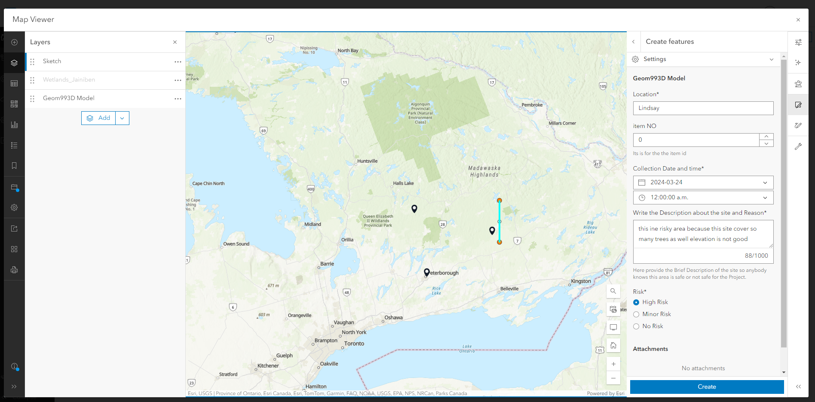

* Here even we can add the layer from the ESRI Living Atlas as well I try to add the 3D layer but it not work we can visualize as 2D only then I try to open that on the Arc Scene as well but not work.

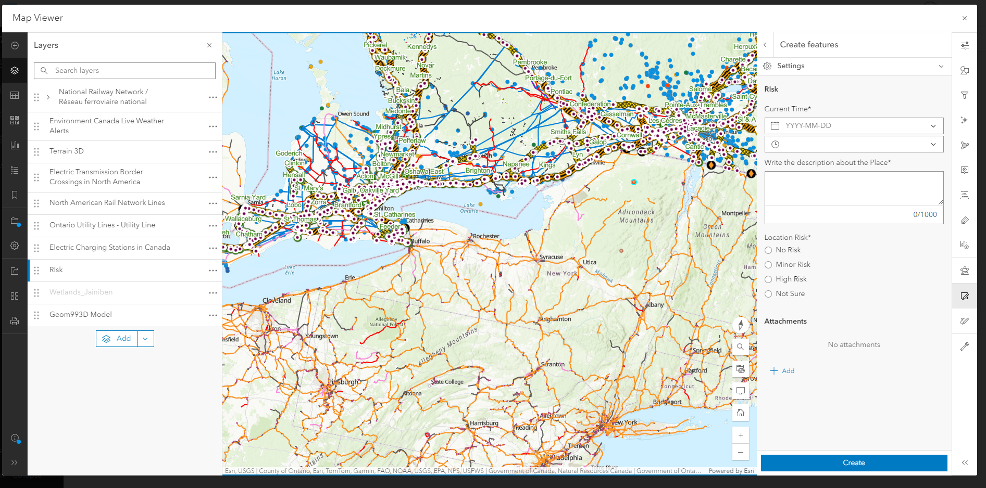

* **Even we can shared that via link as well with the other members.**

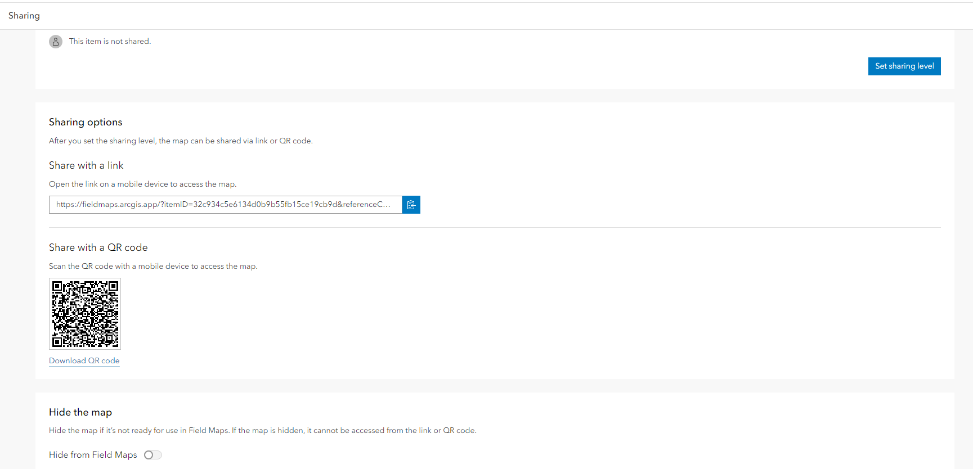

* 25th March 2024,2:00 to 2:15 PM
* This the fist instant I tried to create how its Woking not sure. This time I m not sure how 3D app will work how we can add the data in the app how to set the app the settings.

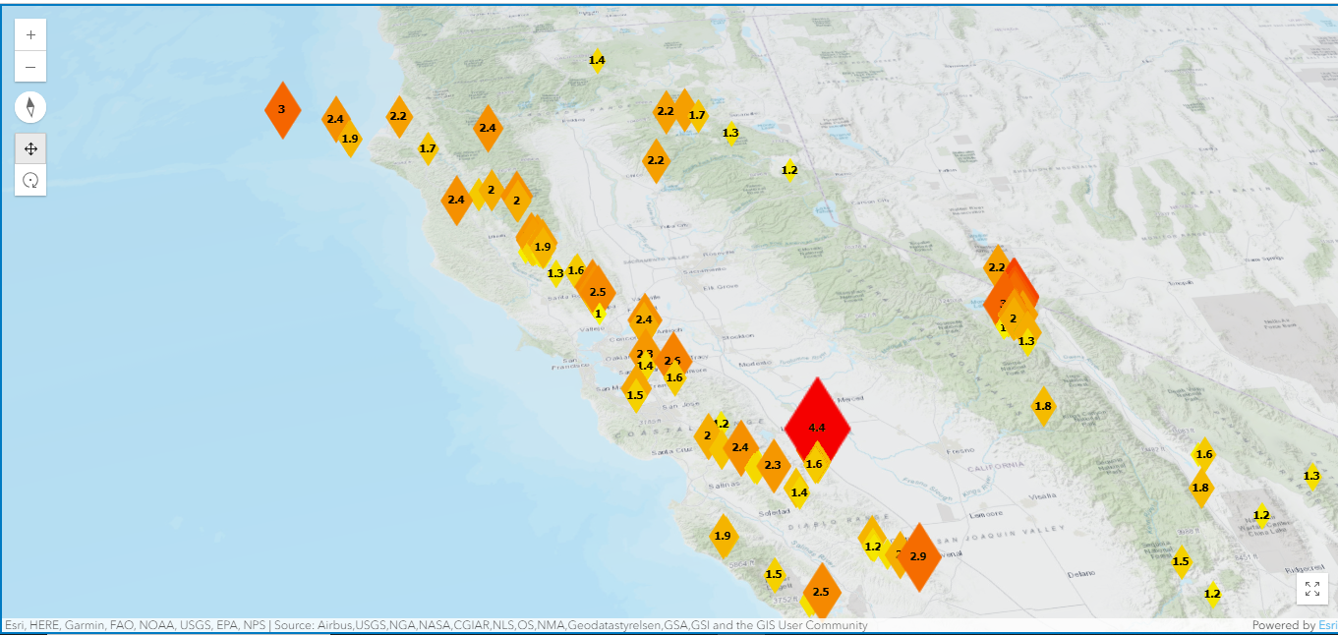

* 26th March 2024, 9:00 to 9:45 AM
* I created the new scene in the ArcGIS Scene Viewer and then save that map and publish on my ArcGIS online Account in this scene I add the two data one is Switzerland Buildings and the Tree 3D data.
* Then I tried to add that Field map layer in this view but in this we can just visualize the data which we collected as 3D but we can not add the point.

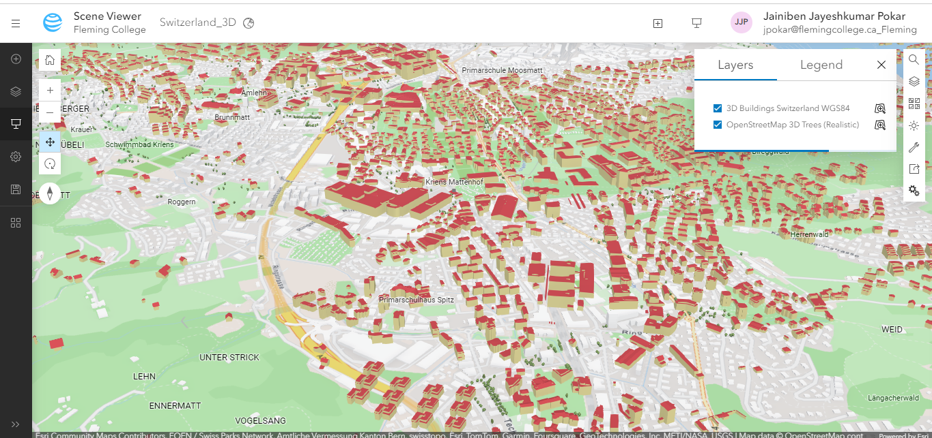

* Then I create the 360 VR using the shortcut creation of app which is the inbuild function in the left side menu I create that for how the out this 3D scene will look in the VR device.
* <https://fleming.maps.arcgis.com/home/item.html?id=b0907b33903f4e5cb73fafabada2a9ec>

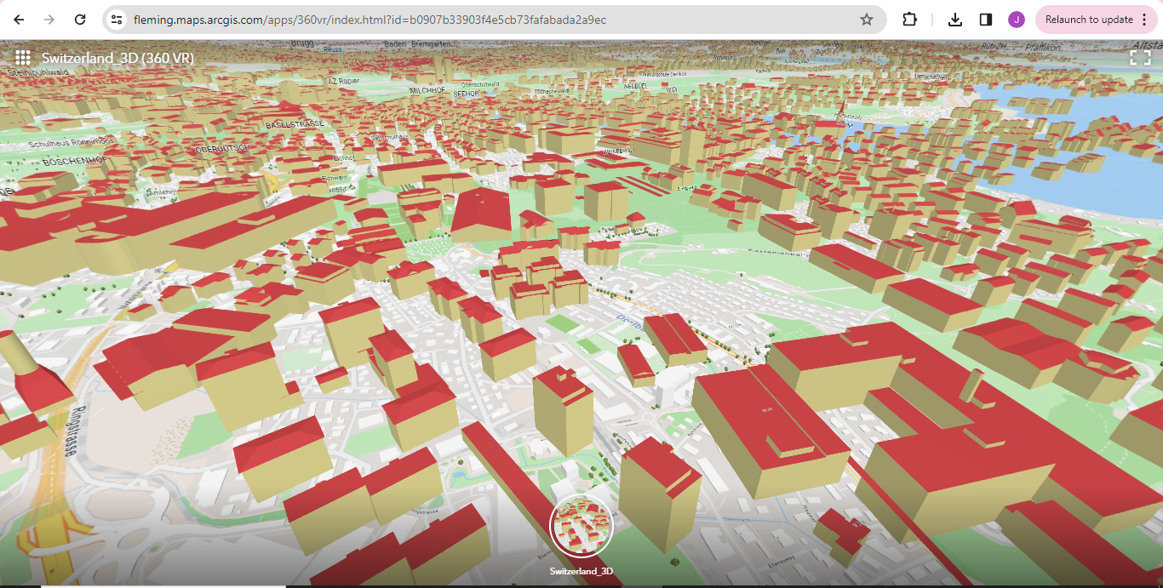

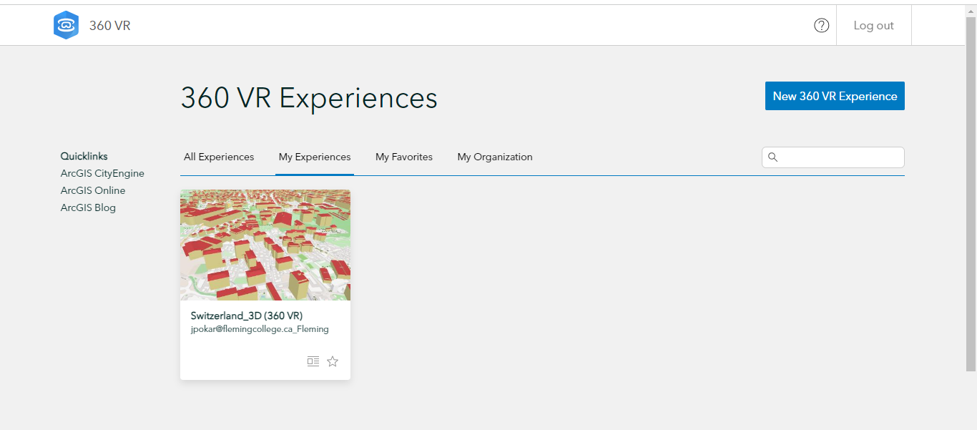

* After that I had meeting with my client from 10:00 to 11:00 and then 11:00 to 12:00 I had meeting with my Advisor.
* 26th March 2024, 6:20 to 6:37 PM
* I tried how ArcGIS Earth work because that application we can open in our phone as well and we can access our all-published map on that application.
* So, I open my scene viewer map on the phone.

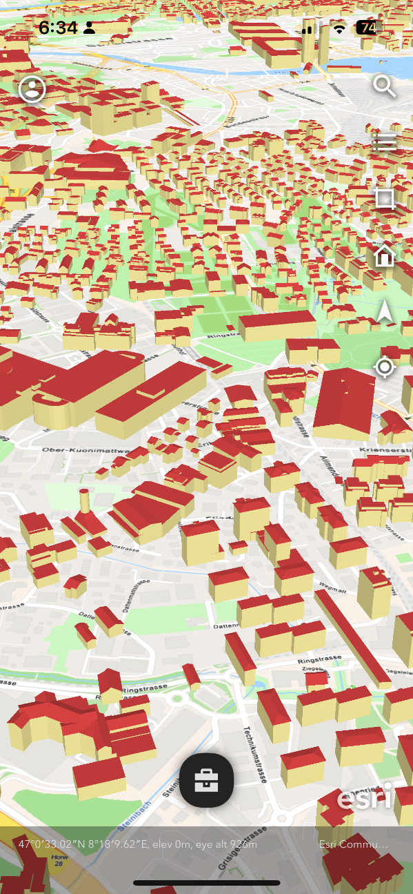

* 27th March 2024, 9:00 to 10:30 PM
* After that I tried to create the Instant app using this scene layer , we can create the App in two way either directly on the instant App.
  + First go to the instant app using ArcGIS online menu -> open the instant app

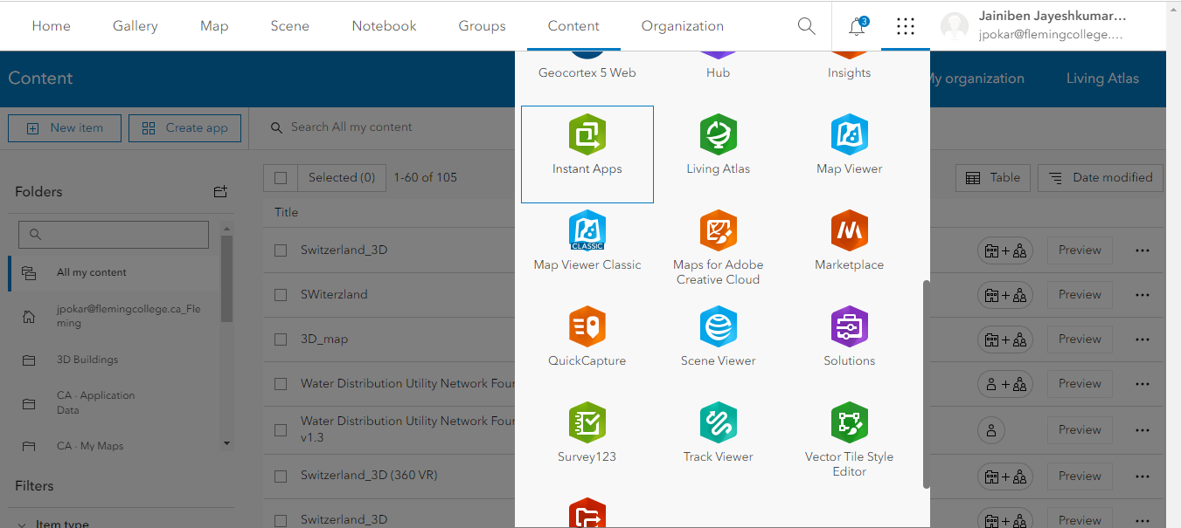

* + Then select the 3D Viewer app and create the application.

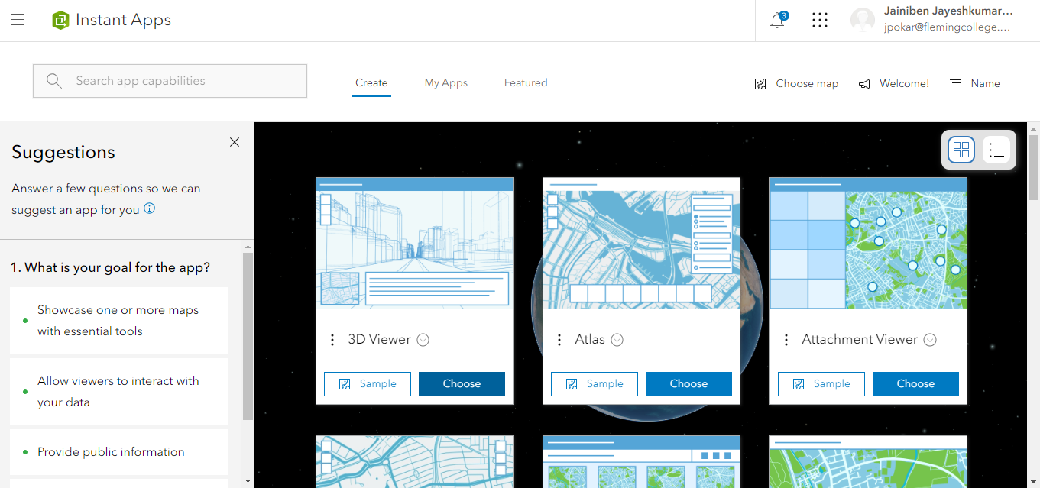

* + Then click on the choose button then one window will pop-up there we have to add the details such as title name of the app ,tags and the which folder you want save.

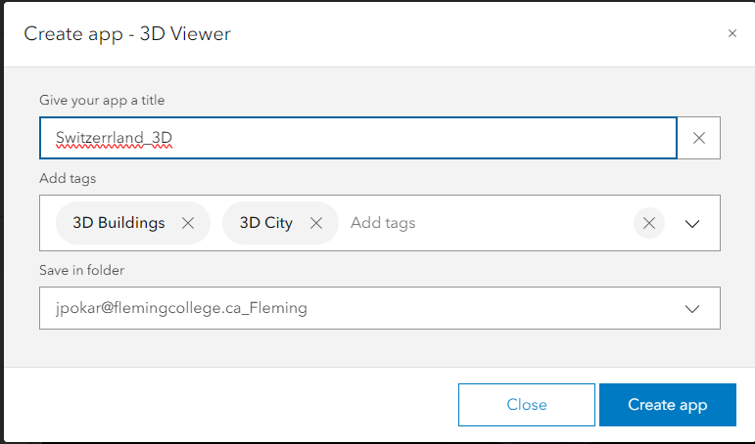

* + Then click create app->open new window there on the left side 4 step are mentioned we have to follow that for creating the application on the very first step we have to select the scene for the application.(Meanwhile my layer is not coming in the app I Don’t know then I close all the ArcGIS and then open everything again and start agian)

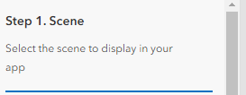

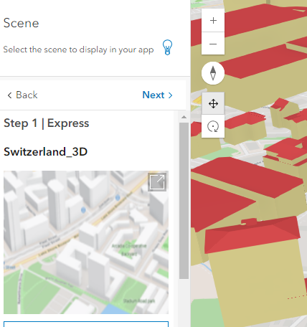

* + Then second step is About there we have to select the some functionality which we want to add in the application like pop-up, legend, shortcut menu and all.

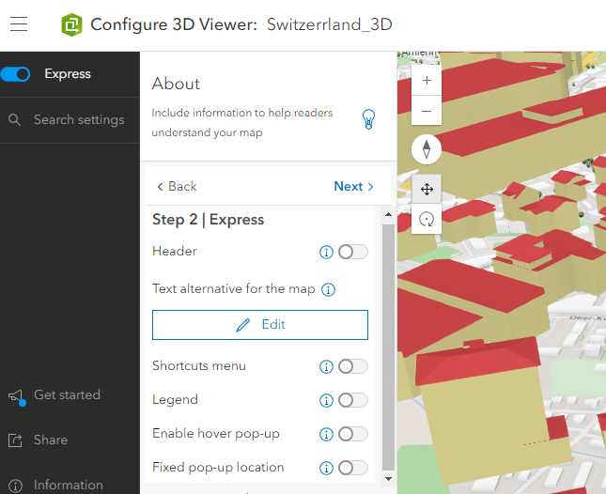

* + We have to enable this option whatever we want to add in the application.in the third step is interactivity here we have to add the sharing, list and all.

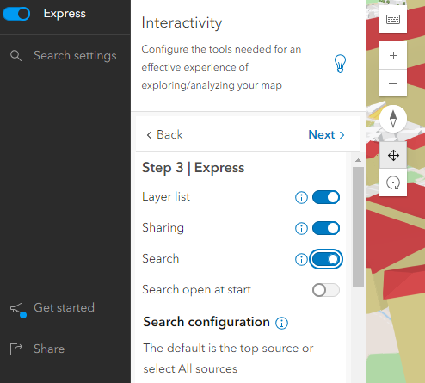

* + And the last step there we have to add the theme and layout here we can select the application them like light or dark mode.

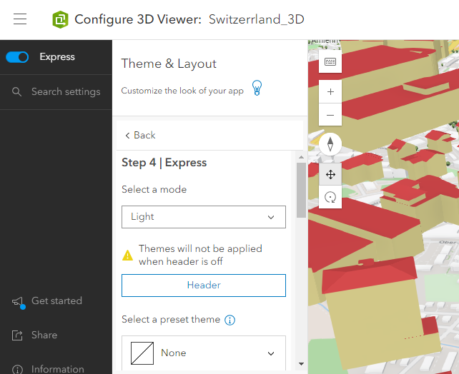

* + Then we have to click the published button(in the screenshot date will look different because I on the configuration mode for taking a screenshot. I forgot to took a screenshot)

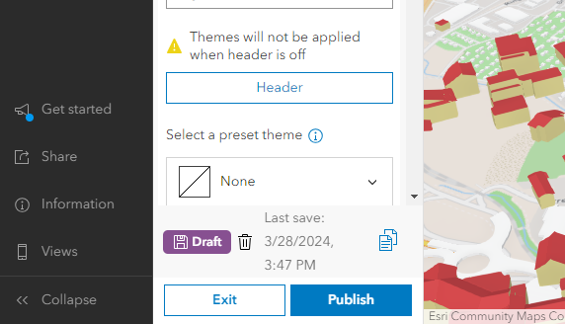

* Second way is too easy you in the ArcGIS scene viewer there is the one option their create app in the left side menu if you click that and select the instant app it will create the 3D view application and you have to follow the same step which we follow for the application and click published. Below you can see the final application layout. <https://fleming.maps.arcgis.com/home/item.html?id=2c5d1dedc73047228c0599d02edb84ca>

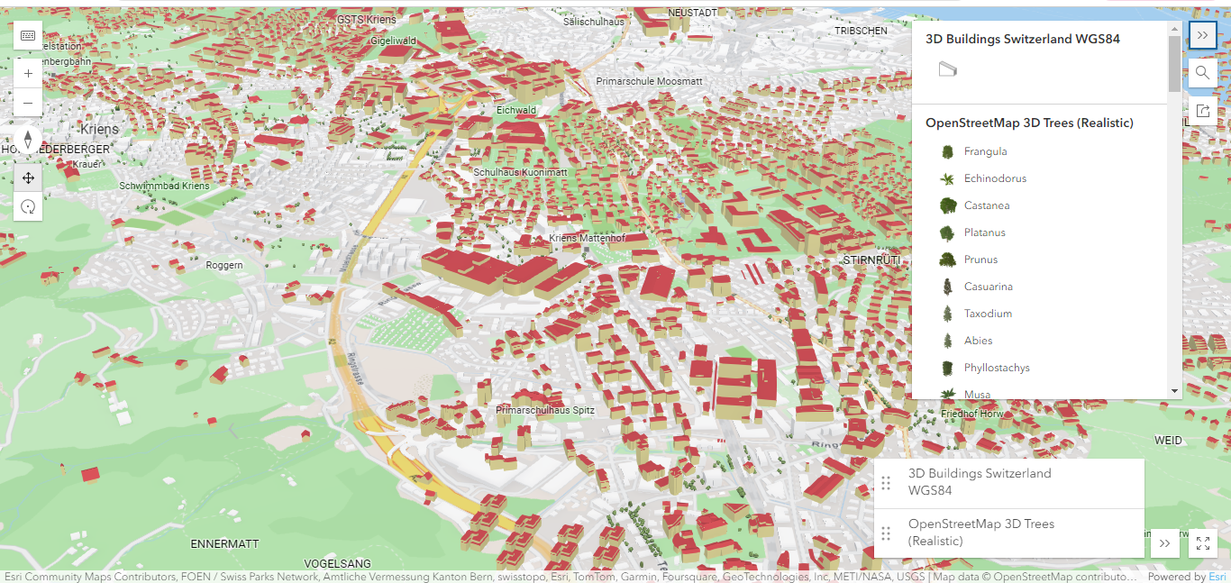

* 29th March 2024, 12:30 to 1:05 PM
* We all did the meeting and discuss on which application we are working and what is the progress of our group then we discussed which application tried and other member try, which application provide the good visualization of 3D data. Me, Nishant and join from my laptop and grace joins us Suruchi is not well she join by message.

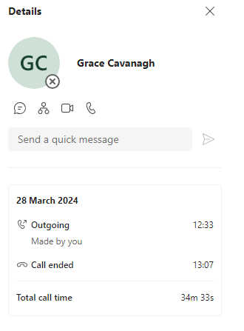

* 29th March 2024, 11:45 to 1:40 AM(Night)
* Again I try one more application for 3D Data Visualization this time I try ArcGIS Experience Builder I never used before but I explore first time in details before that I just did the research on that. <https://fleming.maps.arcgis.com/home/item.html?id=0e008747d28545f48c90fd0188c546a1>
* I started Experience Builder from ArcGIS scene viewer and then I add that map in the experience builder then I used the Launchpad template which I already explore in the research work so I made in the same template.
* We can add below image one function in the our Experienced builder map.

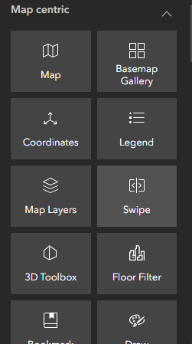

* Even we change the theme as well according our choice and we can add the all functionality whatever we want even here I add the another page and the new window but still don’t not understand how we can see the or change page I tried so many time but failed.

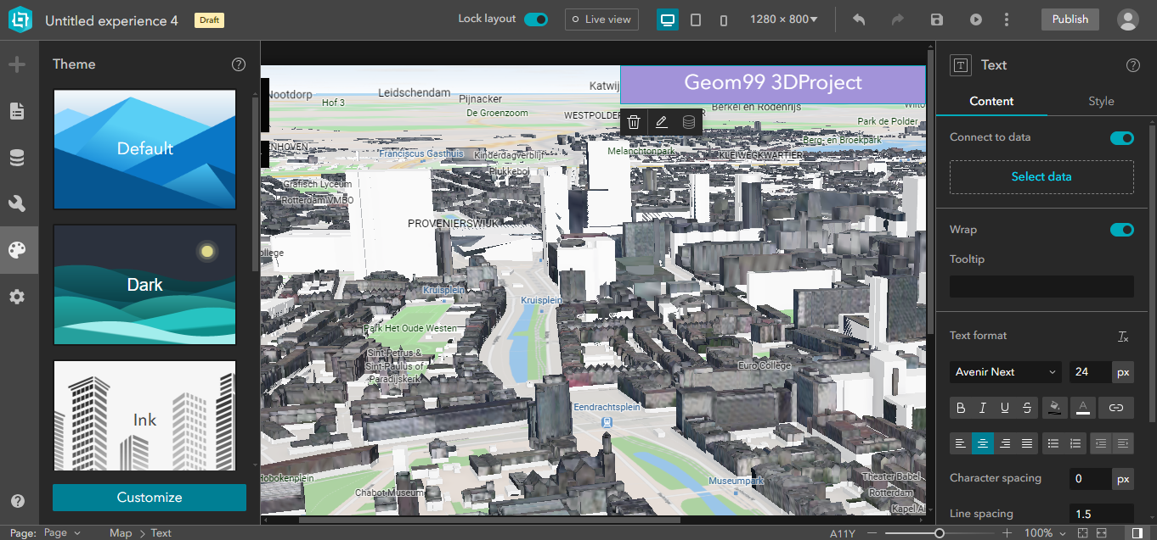

* This is my second page there I add the my web map ,even here I add the graph as well line graph.

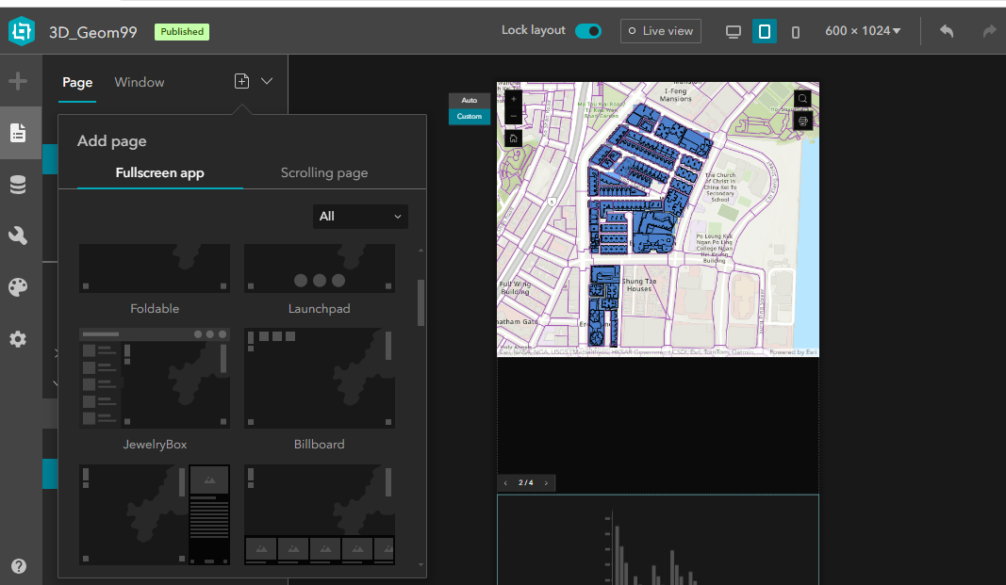

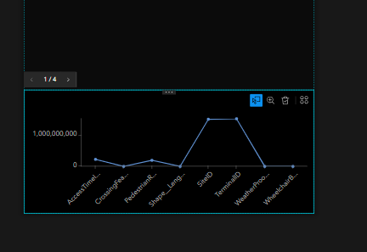

* In below you can see my published one Experienced Builder even I change the data as well because the before 3D data showed the projection error when I add some new layer so io change the data.

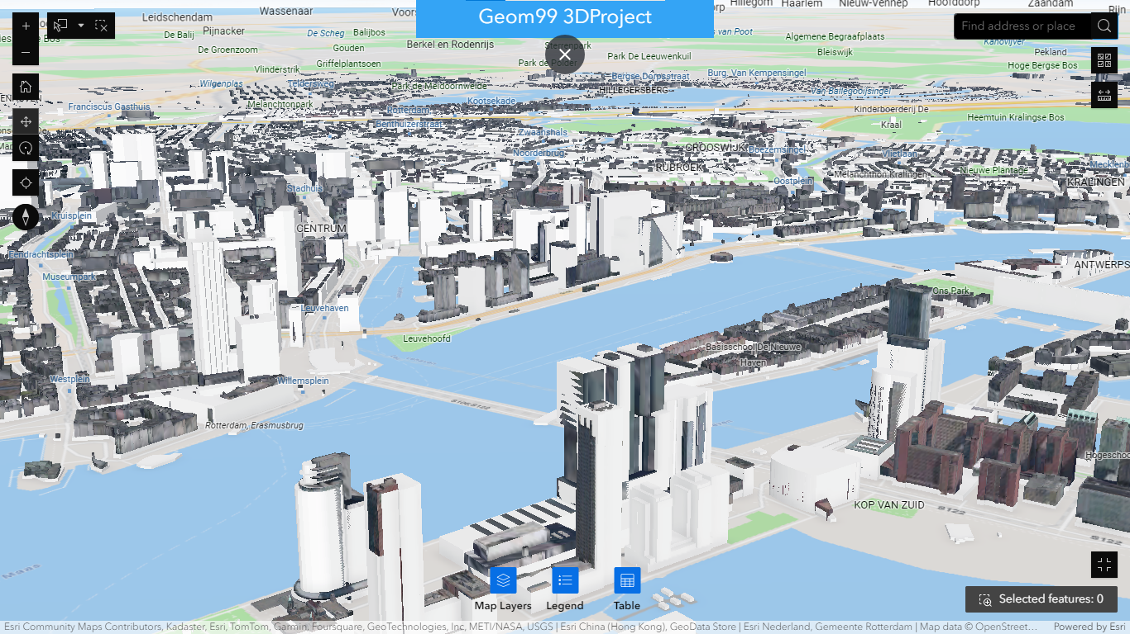

* Even I add the measuring functionality as well we can easily measure the distance between two building and object.

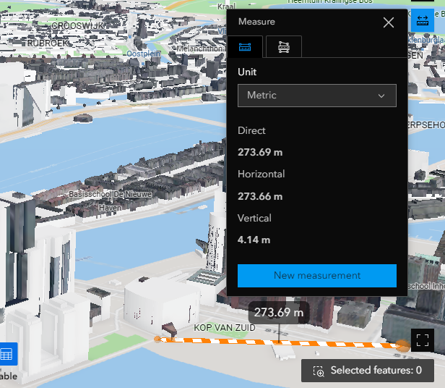

* Then I try to open this same layer in the my phone in ArcGIS Earth application we can add the data in the application by the click the left side menu and select explore ArcGIS gallery here even we can add the ESRI Living atlas map as well and we can add our publish map.

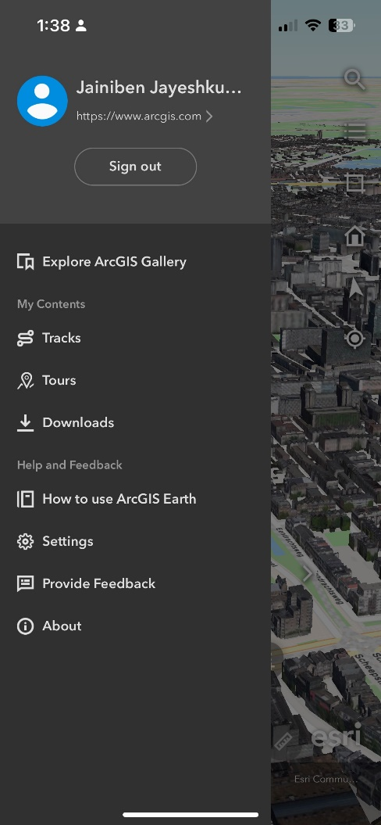

* The go on my content and I select updated one ArcGIS Scene viewer map.

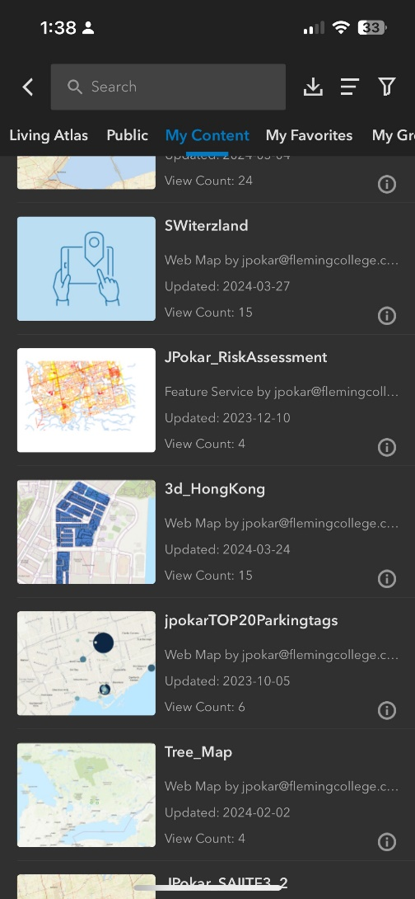

* After that we can see the map in the full screen and there in the bottom one button if we push that button then we can see the more option for the map like draw,3D analysis, Underground, tour, track, measure, and add data. (here I found this underground option will help me in the my Collaborative project because on that I have collect the underground pipeline data and that I have see in the map layer.)

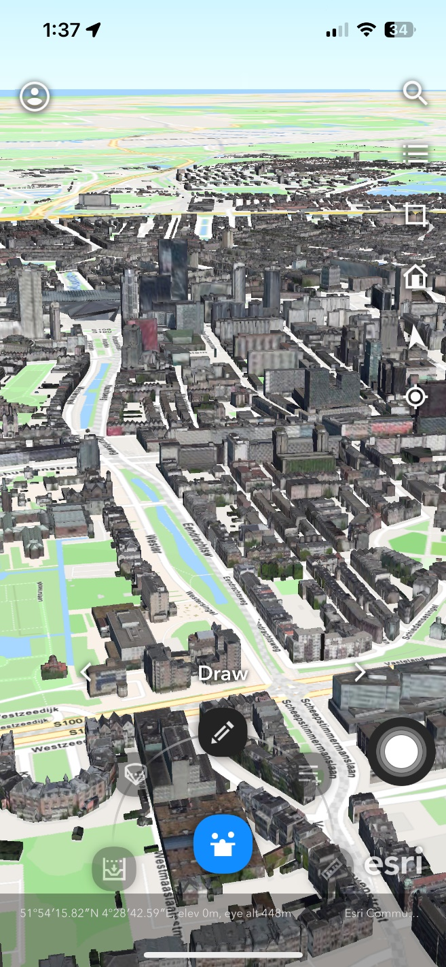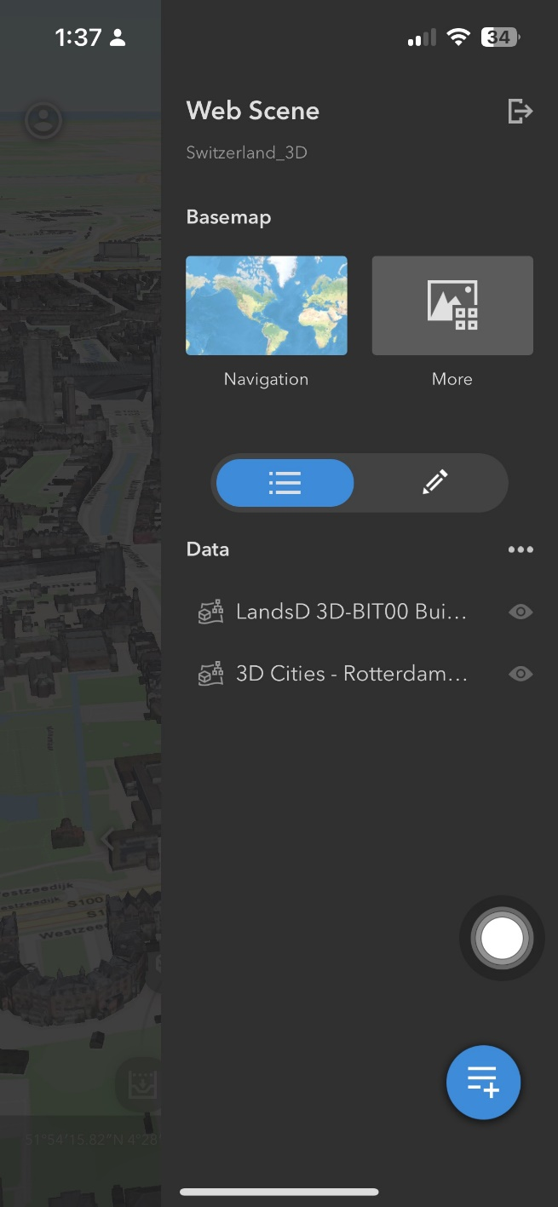

**Total timing: 7 hours 15 minutes**

**Week-13**

* 1st April 2024, 5:10 to 5:30 PM
* I explore that how we can web scene using the ArcGIS SDK so that I go to the documentation of that how we can do: <https://developers.arcgis.com/javascript/latest/tutorials/display-a-web-scene/>
* Then using this ample code, I create my own code for my web scene layer but my map is not showing even I used my API key still. Then I figure out because college system doesn’t support ArcGIS scene viewer.
* 1st April 2024, 6:04 to 6:39 PM
* After that, I went to the Nishant house and we explore the some templet in the W3 School: <https://www.w3schools.com/w3css/tryit.asp?filename=tryw3css_templates_architect&stacked=h> we both like this template and even we seen all past student work. <https://luna.flemingcollege.ca/geom99/>
* 2nd April 2024, 10:49 to 10:52 PM
* We discussed in the group and then grace shared the GitHub repository with use and add us in the GitHub but this time I just see the massage because I am going for the grocery.
* 2nd April 2024, 6:41 to 6:46 PM
* I shared my GitHub account id at 6:10 with her then see add me at 6:41 then I view the template. Because that time I am in the Rahul class so I m doing his class work.
* After the class I am working on the proposal B .
* 3rd April 2024, 10:39 to 11:53 AM
* I recorded the screen from my phone for ArcGIS Earth where we can see the 3D data in the phone.
* For solving the ArcGIS SDK code, I check my past lab code then I do change according that but I still I didn’t get the map then I check all that map in AGOL, after this I figured out that I share that all map in public categories after that I shared my Scene map with everyone instead of organization level. <https://developers.arcgis.com/javascript/latest/tutorials/display-a-web-scene/>
* Then my code is working and I can see the web scene map.

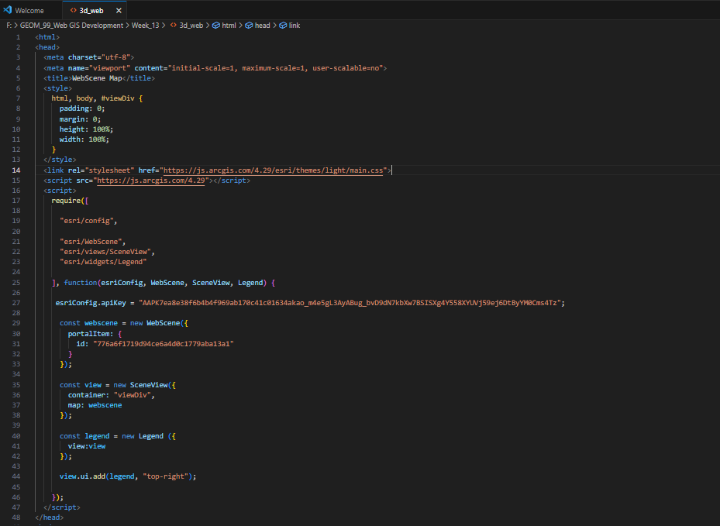

* Writing this code using the same ArcGIS SDK JavaScript Documentation and get this result.

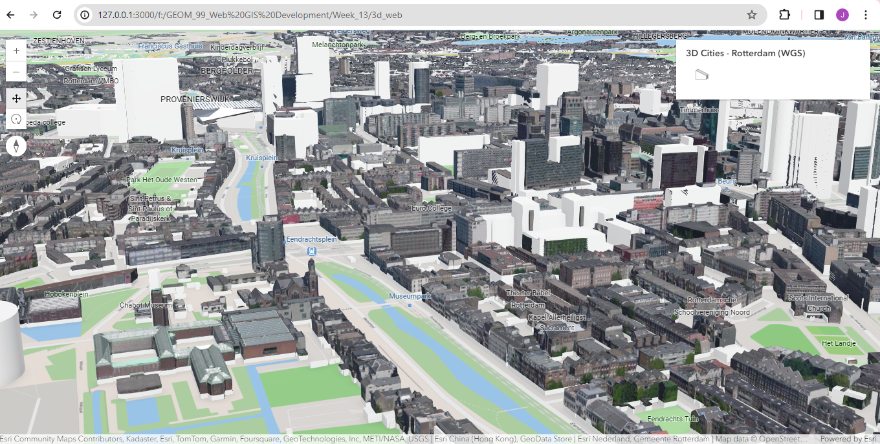

* Meanwhile I send that video to my laptop for adding then I edit on that while recording the video my phone notifications was also recorded so removing that I cropped that from the video.



* then I add new this video into our GitHub website then I found it coming blur so I think I record another.

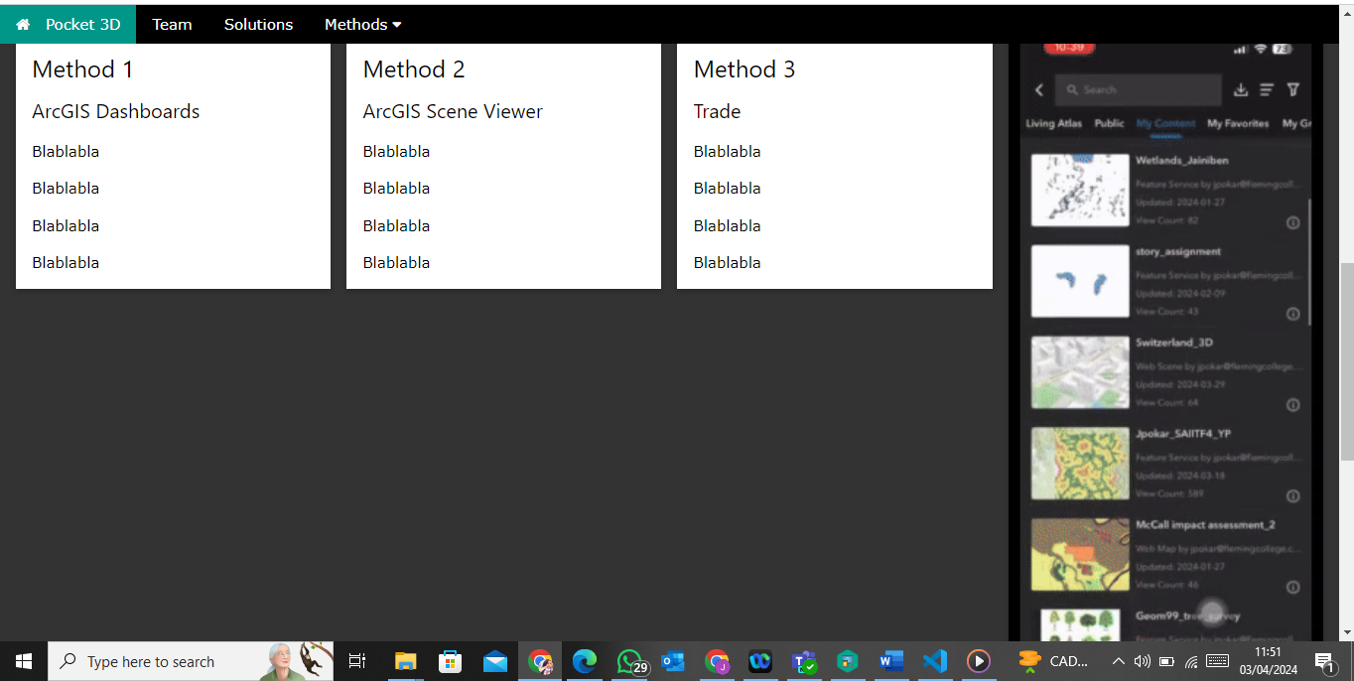

* After this I went to the Marrika’S lab.
* 4th April 2024, 8:45 to 9:30 AM
* I am working on my Experience builder I don’t know I try but still my second page is not coming and even I do the changes according to this video but still is not coming <https://www.youtube.com/watch?v=HjrwJLXq7_c>
* After that I worked on my website stuff for that I connect the GitHub repository in my visual studio.
* I add my basic details and image as well as last time I add the video but due to that error change that as well even I add my image but not coming in the proper shape then I crop the image and add in the code.

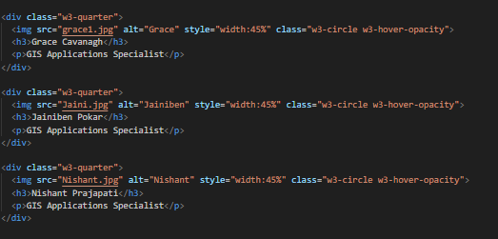

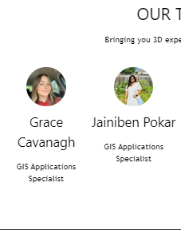

* After I go in my class.
* 4th April 2024, 11:15 to 11:45 AM
* I worked on my ArcGIS earth section I add the basic details of that like what is ArcGIS earth basic and features and all.

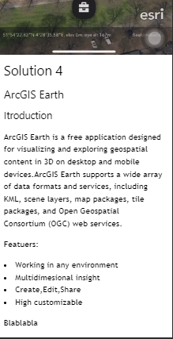

* Then I making the logo for out website in the Canava.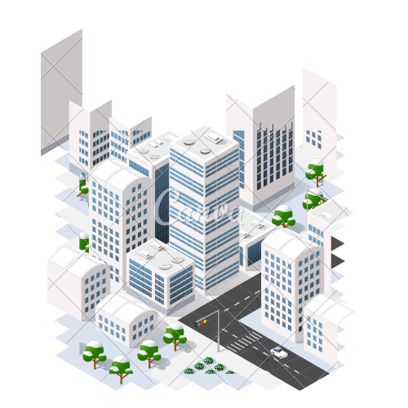
* 4th April 2024, 12:00 to 12:20 PM
* After that we have meeting at 12 with my group so go there for attending the meeting. Around 20 minutes meeting in this meeting we discussed about the how we are working on the website and, then we discuss about the other pages so everyone working on their on-solution page and add then connect that page with the link.
* Even we have some confusion about the which application provide the best result to me then we discussed on that as well then, we decided to write about the stuff like pro and cons of the application on the page as well as what kind of difficulties we face while this experiment.
* 4th April 2024, 2:45 to 4:10 PM
* I add the problem statement on the website , when I add this by default it comes in the left side but for changing the alignment I do some edit on the CSS but then figure nothing will happened on my page even I create class and then I try to give the direct CSS to direct element but still its not gone work then I read the every section of code and understand how they give the CSS to each container because we use the Template.

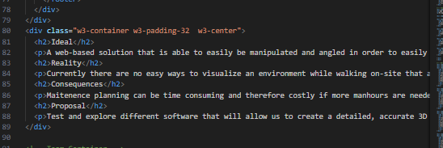

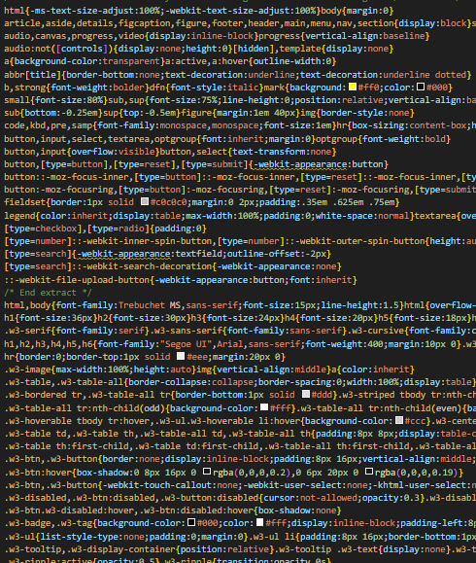

* After looking the whole code and the CSS I see that I have write the in the class bracket and then I add the w3 container and w3 padding then I see the changes I the out put.

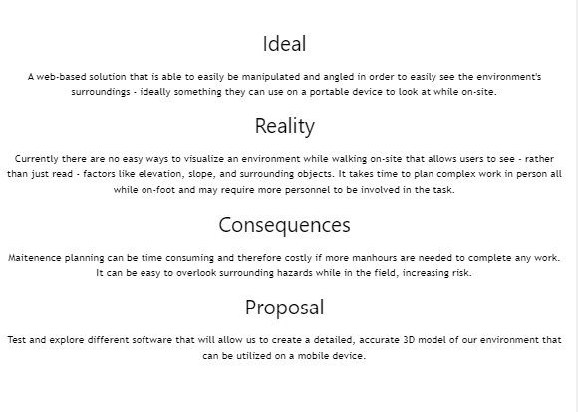

* Before writing like this I change the table format on the w3 but I try that as well but because of that my whole template design will change so I leave it that.

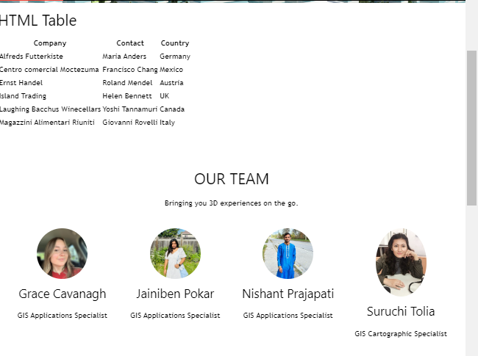

* But in the problem statement even we have only two Colum so leave then I decide I do it that then I will ask my group member how they guys are want then I will make a change.

**Total timing: 5 hours 05 minutes**